Risk Game Project Dissertation

Yichao Xu

***Abstract:***

“Risk” is a classic strategy game in which players try to conquer the world by controlling every territory on a playing board.[1]

Each player will have a group of armies at the start of the game. In each turn, they will be able to reinforce the armies size of own territory and to attack a territory controlled by their opponents. [1]

The project focuses on design, implement, test and evaluates a computer game which follows the rule of the board game “Risk” with three different games AI.

This document is prepared for the final year project supervisor and the players. It will describe the background research, design, implementation and evaluation of the game.

Contents

**1.** **Introduction** 1

**1.1** **Problem Address** 1

**1.2** **Aims and Objectives** 1

**1.2.1** **Game Mechanics** 1

**1.2.2** **Game Aesthetics** 1

**1.3.** **Challenges and Solutions** 1

**1.3.1** **Game Logic Design** 1

**1.3.2** **Game Interface** 2

**1.3.3** **Artificial Intelligent** 2

**2.** **Background** 2

**2.1** **Question Background** 2

**2.2** **Existing Solutions** 2

**2.2.1** **Hasbro Risk** 2

**2.2.2** **Warzone** 3

**2.3** **Research** 3

**2.3.1** **Game Rules Research** 3

**2.3.2** **Game Engine Research** 3

**2.3.2** **Artificial Intelligent Research** 4

**2.4** **Requirements** 4

**3.** **Data Required** 4

**3.1** **Data Needed** 4

**3.2** **Data Sources** 5

**4.** **Revised Design** 5

**4.1** **Use case diagram** 5

**4.2** **Architecture Design** 10

**4.2.1** **View** 10

**4.2.2** **Model** 10

**4.2.3** **Controller** 11

**4.3**  **Abstract Specification** 11

**4.3.1** **Subsystem in View** 11

**4.3.2** **Subsystem in Controller** 11

**4.3.3** **Subsystem in Model** 11

**4.4** **Interface Design** 11

**4.4.1** **Map Board** 11

**4.4.1** **Functional Components** 12

**4.5** **Components Design** 13

**4.5.1** **Classes in View** 14

**4.5.2** **Classes in Controller** 14

**4.5.3** **Classes in Model** 15

**4.6** **AI Activity Diagram** 15

**4.7** **Data structure Design** 17

**4.7.1** **RelationMatrix** 17

**4.7.2** **PriorityOrderedList** 17

**4.7.3** **GameStrategy** 17

**4.7.4** **BalanceGraph and BalanceNode** 18

**4.8** **Algorithm Design** 19

**4.8.1** **Binary Searching** 19

**4.8.2** **FloodMin Algorithm** 19

**4.8.3** **Balance Calculating Algorithm** 20

**4.9** **Test Design** 20

**4.9.1** **System Test Design** 20

**4.9.2** **Cluster Test** 20

**4.9.3** **Unit Test** 20

**4.10** **Evaluation Design** 21

**4.10.1** **Self-evaluation** 21

**4.10.2** **3rd party Evaluation** 21

**4.10.3** **AI Evaluation** 22

**5.** **Realisation** 22

**5.1** **Implementation of View** 22

**5.1.1** **Game Map and UI Components** 22

**5.1.2** **Encapsulation to Unity GUI and WFPS** 23

**5.1.4** **Changes on View Design** 26

**5.1.5** **Problems Encountered in the game view** 27

**5.2** **Implementation of Controller** 29

**5.2.1** **Player Controller** 29

**5.2.2** **Player Controller Manager** 30

**5.2.3** **Command and Invoker** 31

**5.2.4** **Changes on Controller Design** 31

**5.2.5** **Problems Encountered on the game controller** 32

**5.3** **Implementation of Model** 34

**5.3.1** **Data and Data Model** 34

**5.3.2** **Input and Output** 35

**5.3.3** **Artificial Intelligent** 35

**5.3.4** **Changes in Model Design** 39

**5.3.5** **Problems Encountered on the game model** 39

**5.4** **Test** 42

**5.4.1** **System Test** 42

**5.4.1** **Cluster Test** 43

**5.4.1** **Unit Test** 44

**6.** **Evaluation** 45

**6.1** **Functional Point** 45

**6.2** **Self-evaluation** 45

**6.3** **AI Evaluation** 46

**7.** **Learning Point** 47

**7.1** **Lecture Content** 47

**7.2** **Programming Skill** 47

**7.3** **Project Management** 47

**8.** **Professional Issues** 48

**8.1** **Code of Good Practice** 48

**8.2** **Conduct** 48

**9.** **Bibliography** 49

**10.** **Appendices** 51

# **1. Introduction**

## **1.1 Problem Address**

“Risk is a classic strategy game in which players try to conquer the world by controlling every territory on a playing board [2]. Each player will have a fixed number of armies at the start of the game. In each turn, they will receive recruits, and they can place these recruits on any one of her/his territories. After reinforcement, the player will be able to decide if she/he wishes to attack nearby opponent’s territories. The problem that the project tries to solve is how to design, implement and evaluate a risk like game.

## **1.2 Aims and Objectives**

Generally, the aim and object of the project is to design, implement, test and evaluates a turn-based strategy game which is based on the rule of “Risk”, with a computer AI.

Specifically, according to Jesse Schell’s book “The Art of Game Design”[3], a game is composed of the four basic elements, namely, technology: any materials and interactions that make the game possible; mechanics: the procedures and rules of the game; story: the sequence of events that unfolds in-game; aesthetics: game interface design. The document will describe the aims and objects detailly from game mechanics and game aesthetics.

### **1.2.1 Game Mechanics**

Based on the review report from IGN, the game logic design of the board version risk may cause a bad computer game experience [4]. Therefore, the project aims to balance the complexity and entertainment of the game rules, so that both risk game hardcore player and starter will be able to enjoy the digital version risk.

The computer players’ logics are also an essential part of the game mechanics. The project aims to develop three different levels of AI, and they shall follow idiosyncratic logics to act in different situations.

### **1.2.2 Game Aesthetics**

The game interface will directly provide user information and interact with user behaviours. So, the project aims to implement a well-designed world map as the game board, and a set of game UI components which is user-friendly.

## **1.3. Challenges and Solutions**

### **1.3.1 Game Logic Design**

The most challenge part of the game logic design is to identify what are the rules that can be simplified and how to simplify them. Specifically, the challenges of the game logic are a set of mechanisms about how to calculate the battle result, how to count the size of recruits for each player and how to order all players. To solve these problems, the rules of the “Warzone”, a web strategy game based on the rule of Risk, are used as a sample to solve these problems.

In the project, multiple predefined formulas will instead of the dices used in the game. The battle result will be calculated through a non-deterministically function with the armies’ size of attacker and defender as parameters. The design reduces the complexity of the game because the player does not need to choose the number of dices for a battle.

Additionally, there will be a fixed number of guards on all unoccupied areas. This design decreases the player’s payoff of invading an unoccupied area at the early phase. So that, no matter which area a player selects as her/his first territory, the player will only be able to conquer a similar size territory at circa first five turns. Compared with the board game version, the design reduces the geography advantage of each player.

### **1.3.2 Game Interface**

There are a series of challenges in the design and implementation phase for the interface.

The first one is how to design and implement a game map making the game players be able to identify game items such as countries, continents, and enemies. There were three different designs about the game map before the final design is decided. The final design based on the game board of risk game in which the colours will be used to identify different continent, the textures and the number on each area will be used to indicate which player the area is occupied by and the armies’ size on the area. After the design phase is finished, the game map is converted from the visual diagram to mathematic model, and the implementation of the world map is based on the WFPS, a map generation tool released on Unity Asset Store. The final design of the map in the project explicitly identifies different area, continents and each players’ territories, armies.

The second challenge is how to the design and implement the interaction components, such as the button and panel, providing a player-friendly operation method to the players. The design of the game UI based on the design of a classic strategy game “Universal of Europe”. All buttons are set on the top of the game interface, and two additional panels are used to show all players information. The game interface implemented is based on the unity graph tools.

### **1.3.3 Artificial Intelligent**

There will be three different levels of game AI in the project and design of these AI will follow the pattern noted in the “multiple agent” module. The computer players will first observe the game map, after that they will predicate the result for their possible actions. When they finish the prediction, they will select an action and execute it. Therefore, the main challenges about the AI include how to construct and maintain a model about the game for each computer player, how to calculate the payoff of each action and how to make the final decision.

The project implements an algorithm to build the undirect graph for describing the map and a “Flood-Max” like algorithm to estimate the result of the player’s action. In the game, three different levels of artificial intelligence are implemented and the time complexity of the algorithm is O(nm) in which n is the number of the countries m is the diameter of the diagraph[5].

# **2. Background**

## **2.1 Question Background**

The market of the digit game is rapidly increasing. According to the data published by “The Association for UK Interactive Entertainment”[6], the global game market for the video game is estimated to reach 180 billion US dollar by 2021 and the UK game market will worth 5.2 billion dollars in 2021 growing at 6.7% per-year currently. A survey called “The Best Board Games of All Time”[7] collects 40.8 thousand participants’ view about the board game lists. The “Risk” is list as the second most popular board games based on the result of the survey.

## **2.2 Existing Solutions**

### **2.2.1 Hasbro Risk**

Hasbro has already released various computer and mobile phone version Risk game, such as the Risk: Factions, Risk: Golden, Risk II [4][8][9]. The digital version risk implements all feature of the board game version with various new game models and functions [4].

Compared with the game implemented in the project, it more premium in many aspects such as the UI design, game aesthetic and operation design, but the simple copy of the rules makes playing the game be a lengthy affair. It could keep gamers tethered to their device for hours and hours before a victor is declared [4].

### **2.2.2 Warzone**

“Warzone” is a strategy game basing the gameplay of the risk. It is a web-game which follows the most rules of Hasbro risk and simplify some of them [10]. There is an excellent game logic design in “Warzone”. Optimisation of the board version risk makes the average time for playing the game be less than 15 min.

Compared with the risk game implemented in the project, “Warzone” is better in the rules design and game aesthetic. But the game is browser-based so that the game has to face the different version of the browser. It may be incompatible with some browser like IE6, and the browser limits the complexity of the algorithm in the game.

## **2.3 Research**

### **2.3.1 Game Rules Research**

A series of researches about the game design has been done for implementing the objects about the game rules noticed in the document.

* The design of the game rules follows the design principles introduced in an online course from Cousera named Introduction of Game Industry [11].
* The method in Jesse Schell’s book “The Art of Game Design” [12] is used to identify a game aims and requirements.
* The gameplay of the game is inspired by the “Warzone” which is an online risk-like game.

### **2.3.2 Game Engine Research**

The game engine is a critical component to implement the project because, it minimizes the complexity of visual processing that may occur in the project such as drawing the sharp of an area, colourising different continents and highlighting the players’ territories. There are various engines can be used to implement the game.

JMonkey Engine is an open source desktop game engine [13]. Compared with other engines list in the document, it is the only one which supports (and only support) Java as the programming language to develop a game. It will reduce the expenses of learning a new programming language because I am already familiar with the syntax and feature of the programming language. However, even if Java is perfect for the project, the most features in the engine is outdated and clumsy compared with the other two engines in the document.

PlayCanvas Engine is an open source web game engine [14]. The engine supports almost all browsers on both desktop and mobile devices. It endows the game a strong capability of cross-platform. Also, the engine supports JavaScript as the game developing language. Because I have learned its syntax in the module scripting language, it will not be too hard to adapt the language. But it is impossible to implement complex game logic and algorithm through the game engine because of the browsers’ limitation.

Unity Engine is one of the most famous commercial game engines [15]. It provides a powerful IDEA for implementing game logic and a set of preset resources for developing the game view. All games based on the engine can run on different platforms, such as Android, IOS, Mac, Win, etc. Also, the unity asset store provides many assets which can be directly used in the project to reduce the developing time. However, if Unity is used as the game engine of the project, it is more time-consuming compared with the previous two engines due to the programming language can only be C# whose syntax is Java-like but more complicated

Finally, the Unity Engine is decided as the game engine of the project. To adapt the unity engine and the C# language, A series of researching and reading about them have been done:

* A course named “Introduction of the Unity Engine” on Coursera help me to be familiar with how to implement a game through Unity Engine.
* Jennifer Greene’s book Head first C# help to adapt the basic syntax of the C# language.

### **2.3.2 Artificial Intelligent Research**

In Michael Wolf’s thesis “An Intelligent Artificial Player for the Game of Risk” [15], he implements three kinds of game AI for risk game. The previous two computers AI is an alpha-beta like algorithm, and the final one implements a Temporal Difference Learning algorithm. Based on his research, the game tree complexity of the risk is Branching Factor ^ Game Turns. Therefore, the State-Space Complexity a risk game which exists 200 armies attach 1047 and the game tree complexity for such a game attach 102350 [15].

## **2.4 Requirements**

* The game will be turn-based, and turn rotates among players.
* The total number of human and computer players shall be from two to six.
* The game shall provide three different game types, namely “Player versus Player”, “Player versus Computer” and “Computer versus Computer”.
* At the start of a game, each player shall have the same number of armies, and be able to select an area as own first territory.
* At the beginning of each turn, calculate how many recruits the player will add to her/his territories based on the number of the player’s territories and the value of the continents her/his control.
* In each turn, the player shall be able to place their all recruits on her/his territories, and the undeployed recruits shall be discarded at the end of the turn.
* After placing the recruits at, the player shall be able to decide if she/he wishes to attack at this time. If the player decides to attack, she/he needs to announce the target area and the territory, from which attack comes.
* The result of the battle shall be calculated through a non-deterministic algorithm based on their armies’ size.
* Additionally, the player shall be able to move armies from one of the own territories into an adjacent territory.
* The winner shall be the player who eliminates all other opponents and occupies all 42 areas.
* The game map shall be divided into forty-two area and these areas shall belong to six different continents.
* Continents’ surface is covered in different colours.
* The action of each player, such as dispatching armies, invading territories and attacking enemies, shall be displayed on the game map.
* The additional game interface components shall be provided to make the human player be able to place recruits, attack opponents or move armies.
* The number of recruits and the colour for each player will be shown on the screen.
* The human player shall be able to decide the number and to select the type of computer player before the game starts.
* The game shall provide three different levels of AI player.

# **3. Data Required**

## **3.1 Data Needed**

The data used in the project are what the design of the game board and geographic division of the game area.

## **3.2 Data Sources**

The design of the game board is based on the board design of Hasbro’s board game risk[1]. And the geographic division on the map accords to an online web game named the “Warzone” [16]

# **4. Revised Design**

Compared with specification and design document, the design of the game in this document is completely changed except the use case diagram.

Generally, the project will firstly describe the requirements for the game through the use case diagram. After that, it will follow the software design process, namely, architecture design, abstract specification, interface design, components design, and algorithm design to describe the game program design.

**4.1 Use case diagram**

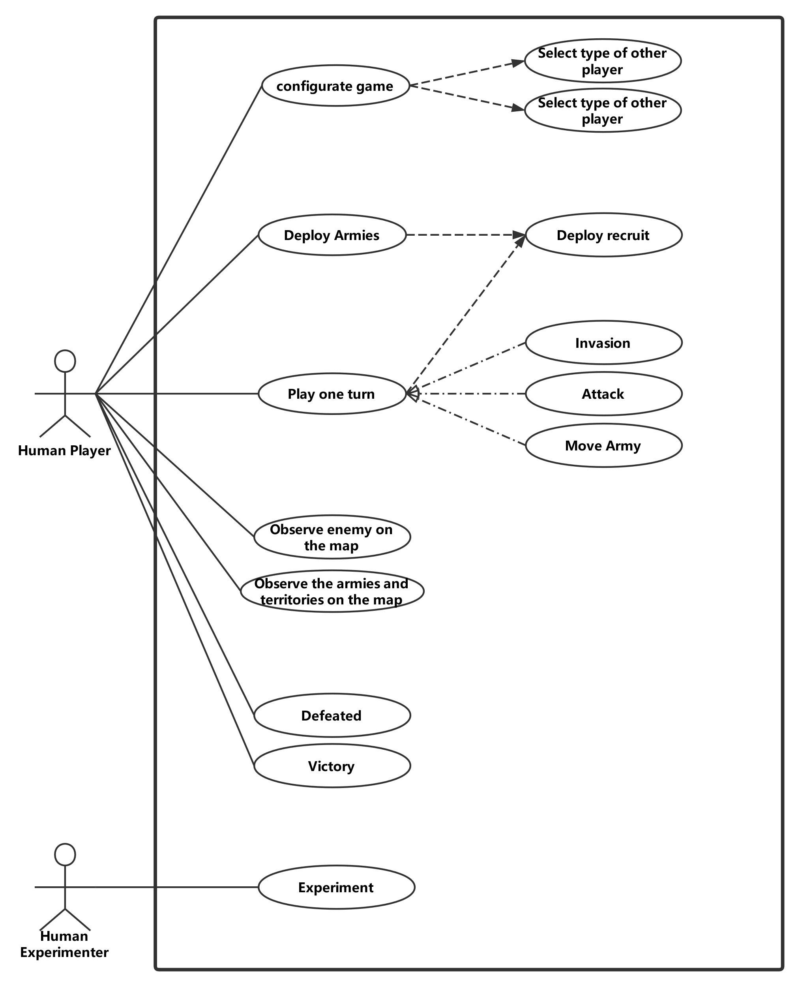

Figure 1 Use case Diagram

|  |  |
| --- | --- |
| **ID** | UC1 |
| **Name** | Configure game |
| **Description** | The user configures the game before starting a new game. |
| **Pre-conditions** | There is not any information about the number and the type of player. |
| **Event flow** | The game system shows the user a guide of configuration. include UC2() include UC3() Generate the game based on the data from UC1 and UC2 |
| **Post-condition** | The game has been generated according to the collected data. |
| **Includes** | UC2, UC3 |
| **Extensions** | None |
| **Triggers** | A game user click button “Start Game” |

|  |  |
| --- | --- |
| **ID** | UC2 |
| **Name** | Input number of the player |
| **Description** | The user inputs the number of the game player. |
| **Pre-conditions** | The system doesn’t know the number of players. |
| **Event flow** | At first, the game system requires the number of players from the user. After the user types a number, the system will check the validation. **if** it is valid,   the system will store the number of the player. **else**  the system will notify the user, the number is invalid. |
| **Post-condition** | The number of the player has been stored in the system. |
| **Includes** | None |
| **Extensions** | None |
| **Triggers** | A game user click button “Start Game” |

|  |  |
| --- | --- |
| **ID** | UC3 |
| **Name** | Select type of other players |
| **Description** | The user selects the type of another player in the game. |
| **Pre-conditions** | The system doesn’t store any information about other players  The system has stored the number of players. |
| **Event flow** | **for** all other players,  the user selects the player type from (human, simpleAI, normalAI, HardAI).  and then, it will be recorded in the system |
| **Post-condition** | The system has recorded the type of all players. |
| **Includes** | None |
| **Extensions** | None |
| **Triggers** | UC2 has been finished. |

|  |  |
| --- | --- |
| **ID** | UC4 |
| **Name** | Deploy Armies |
| **Description** | The human player deploys its armies at the start of the game. |
| **Pre-conditions** | A player doesn’t deploy the armies and the game is still in the configuration phase. |
| **Event flow** | **for** each recruit in the configuration phase  include UC5() |
| **Post-condition** | The player doesn’t have undeployed armies. |
| **Includes** | UC5 |
| **Extensions** | None |
| **Triggers** | The configuration turn of the player starts. |

|  |  |
| --- | --- |
| **ID** | UC5 |
| **Name** | Deploy recruit |
| **Description** | A human player deploys its recruit on the map. |
| **Pre-conditions** | The player has an undeployed recruit and in the recruiting phase. |
| **Event flow** | select a province on the map **if** it has already been occupied by the player,  the number of the armies on the province plus one. **if** it has already been occupied by another player,  abort the deployment. **if** it is unoccupied,  allocate the province to the player   set the number of armies on the province to be one. |
| **Post-condition** | The size of the player’s armies plus one. |
| **Includes** | None |
| **Extensions** | None |
| **Triggers** | The player clicks the allocate button. |

|  |  |
| --- | --- |
| **ID** | UC6 |
| **Name** | Invasion |
| **Description** | A human player’s armies invade the other player’s territory. |
| **Pre-conditions** | One of the player’s armies is on the boundary and in the attack phase. |
| **Event flow** | The user selects an army on the boundary. After that, move the army into an enemy’s province which is ungarrisoned Then, the player occupies the province. |
| **Post-condition** | The number of the player’s provinces plus one |
| **Includes** | None |
| **Extensions** | None |
| **Triggers** | The player drags an army on the belligerent’s ungarrisoned province |

|  |  |
| --- | --- |
| **ID** | UC7 |
| **Name** | Attack |
| **Description** | A human player’s one of the armies attacks the enemy and in the attack phase. |
| **Pre-conditions** | One of the player’s armies is nearby the enemy. |
| **Event flow** | The user selects an army on the boundary. After that, move the army into an enemy’s province which is garrisoned Then, the system calculates the result of the battle The armies of the defeated party will be annihilated The province will be occupied by the winner. |
| **Post-condition** | One of the belligerents’ armies on the province is annihilated |
| **Includes** | None |
| **Extensions** | None |
| **Triggers** | The player drags an army on the belligerent’s garrisoned province |

|  |  |
| --- | --- |
| **ID** | UC8 |
| **Name** | Move Army |
| **Description** | A human player moves the army between own provinces. |
| **Pre-conditions** | The number of the army of the player is not zero and the player is in the attack phase |
| **Event flow** | The user selects an army. After that, move the army into its own province Then, the number of garrisons plus one. |
| **Post-condition** | The allocation of the player’s armies is changed |
| **Includes** | None |
| **Extensions** | None |
| **Triggers** | The player drags an army on the belligerent’s garrisoned province |

|  |  |
| --- | --- |
| **ID** | UC9 |
| **Name** | Play one turn |
| **Description** | A human player plays one turn of the game. |
| **Pre-conditions** | The player doesn’t be defeated. |
| **Event flow** | The game turn starts. the player enters the Deploy Phase,  **for** each recruit do  include to UC5(); **for** each army in the map do  **if** the user decides to invade  include to UC6();  **if** the user decides to attack  include to UC7();  **if** the user decides to move  include to UC8(); end the game turn |
| **Post-condition** | The player ends the turn. |
| **Includes** | None |
| **Extensions** | UC5, UC6, UC7, UC8 |
| **Triggers** | The player turn starts. |

|  |  |
| --- | --- |
| **ID** | UC10 |
| **Name** | Observe enemy on the map |
| **Description** | A human player observes the location and the number of armies or provinces of other players. |
| **Pre-conditions** | The player currently doesn’t be defeated. |
| **Event flow** | Observe provinces and armies on the map. |
| **Post-condition** | The player has observed the enemy. |
| **Includes** | None |
| **Extensions** | None |
| **Triggers** | The player is going to observe the enemy. |

|  |  |
| --- | --- |
| **ID** | UC11 |
| **Name** | Observe own armies and provinces |
| **Description** | A human player observes the location and the number of own armies or provinces. |
| **Pre-conditions** | The player currently doesn’t be defeated. |
| **Event flow** | Observe provinces and armies on the map. |
| **Post-condition** | The player has observed own armies and province. |
| **Includes** | None |
| **Extensions** | None |
| **Triggers** | The player is going to observe own armies and provinces. |

|  |  |
| --- | --- |
| **ID** | UC11 |
| **Name** | Victory |
| **Description** | A human player wins the game. |
| **Pre-conditions** | The player is the last player of the game. |
| **Event flow** | The game system finds that the player is the last player of the game. After that, the system shows a notification to the player. |
| **Post-condition** | The game is over, or the player is removed from the game. |
| **Includes** | None |
| **Extensions** | None |
| **Triggers** | UC2 require remotely authenticated service |

|  |  |
| --- | --- |
| **ID** | UC12 |
| **Name** | Defeated |
| **Description** | A human player is defeated. |
| **Pre-conditions** | The number of the player’s armies and provinces is zero. |
| **Event flow** | The player’s last province has been occupied by an enemy. The system checks the number of human players. **if** the number is zero,  Game over and conclude the result of the game; **else  the** game continues,  but the player will be removed from the game; |
| **Post-condition** | The game is over, or the player is removed from the game. |
| **Includes** | None |
| **Extensions** | None |
| **Triggers** | UC2 require remotely authenticated service |

|  |  |
| --- | --- |
| **ID** | UC13 |
| **Name** | Experiment |
| **Description** | A human experimenter to exam the AI system. |
| **Pre-conditions** | The game system is running. |
| **Event flow** | The experimenter clicks the “Simulating” button on the main menu.  The experimenter decides types of two computer players. The system automatically generates and logs the result of the game. |
| **Post-condition** | The game is over, and the game log has been produced. |
| **Includes** | None |
| **Extensions** | None |
| **Triggers** | The experimenter clicks the “Simulating” button on the main menu. |

**4.2** **Architecture Design**

The diagram below shows the subsystems context model of the game program. It is clear to see that the architecture pattern of the game program is “Model-View-Controller”.

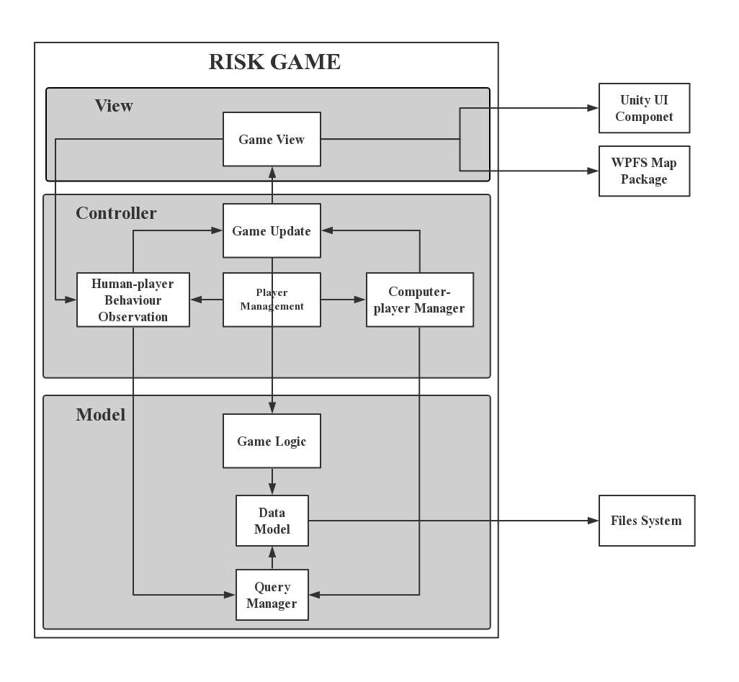

Figure 2 Context Model of Risk

### **4.2.1 View**

In term of game view, a package named WPFS and another package named Unity GUI is used to implement the user interface. These external APIs reduce the complexity of the project developing but decrease the portability of the game core. Therefore, the game view is designed as a set of encapsulation class which wraps external APIs to solve the problem.

### **4.2.2 Model**

The model part manages the possible data I/O and maintains the data model, such as the relationship between different areas, continents, players’ armies, and territories, etc. It also implements all algorithms about the game logic. It includes “Game Logic System”, “Query Management System” and “Data Model System”.

### **4.2.3 Controller**

The controller is designed as the communication medium between the game model and game view. In the game program, it is in charge of allocating the game turn to each player, monitoring human-players’ behaviours and updating the game view. It includes “Game Updating System”, “Human-player Behaviour Observation System”, “Computer-player AI System” and “Player Management System

**4.3 Abstract Specification**

### **4.3.1 Subsystem in View**

Generally, the “Game View System” is a subsystem in the game view which warps the external API referring to the game map and user interface. Specifically, it handles the map colourisation, the

Overall, the “Game View System” is the encapsulation of external API referring to the game map and user interface. Specifically, the subsystem wraps the method of Unity GUI and WPFS package, so that it provides a set functions to update the game interface. Also, it can receive user behaviours such as the move the mouse, click button or areas on the map and send message to human behaviours observation system through events.

### **4.3.2 Subsystem in Controller**

“Human-player Interaction System” interprets the possible behaviours of human-players during their playing the game. the subsystem translates messages from “Game View System” with the information from “Data Query System” to various instructions to the “Game Update System” and for updating the game view and game model respectively.

“Computer-player AI System” is the implementation of the game AI. The subsystem consists of all computer players in the game. It is able to build a acknowledge model for the game from the “Data Query System” after that generate a strategy for the computer player and delivery the strategy to “Game Update System”.

“Player Management System” controls both “Human-player Interaction System” and “Computer-player AI System”. The duty of the subsystem is to decide which player the current game turn belong to.

“Game Updating System” receives instruction from both human and computer player to update the game view and model through its communication between the “Game View System” and “Game Logic System”.

### **4.3.3 Subsystem in Model**

“Game Logic System” implements all game logic in the game model. The result of a player’s action such as attack, movement and reinforcement will be calculated in the subsystem. It will receive the message from the “Game Updating System” and directly updates “Data Model System”.

“Query Management System” provides both “Human-player Interaction System” and “Computer-player AI System” a set of APIs to query the data store in the “Data Model System”. The design reduces the coupling between the controller and the model.

“Data Model System” is the core of the game data because, all data about the game are stored in the subsystem such as the neighborship of each area, the armies and territories of a player, etc. It directly communicates with the file system to write or read the game record.

**4.4 Interface Design**

In this part, the document will describe the design of the game user interface. The user interface of the game will consist of two parts namely, the map board and functional components.

### **4.4.1 Map Board**

The game map shall clearly show the continents, bounder of each area, the players ‘territories and armies. The figure 3 below shows the design of game map: When the game start, the different continents are covered by different colours and there will be a label on each area showing the size of local armies or guardians. In addition, different player’s territories are filled with different colours.



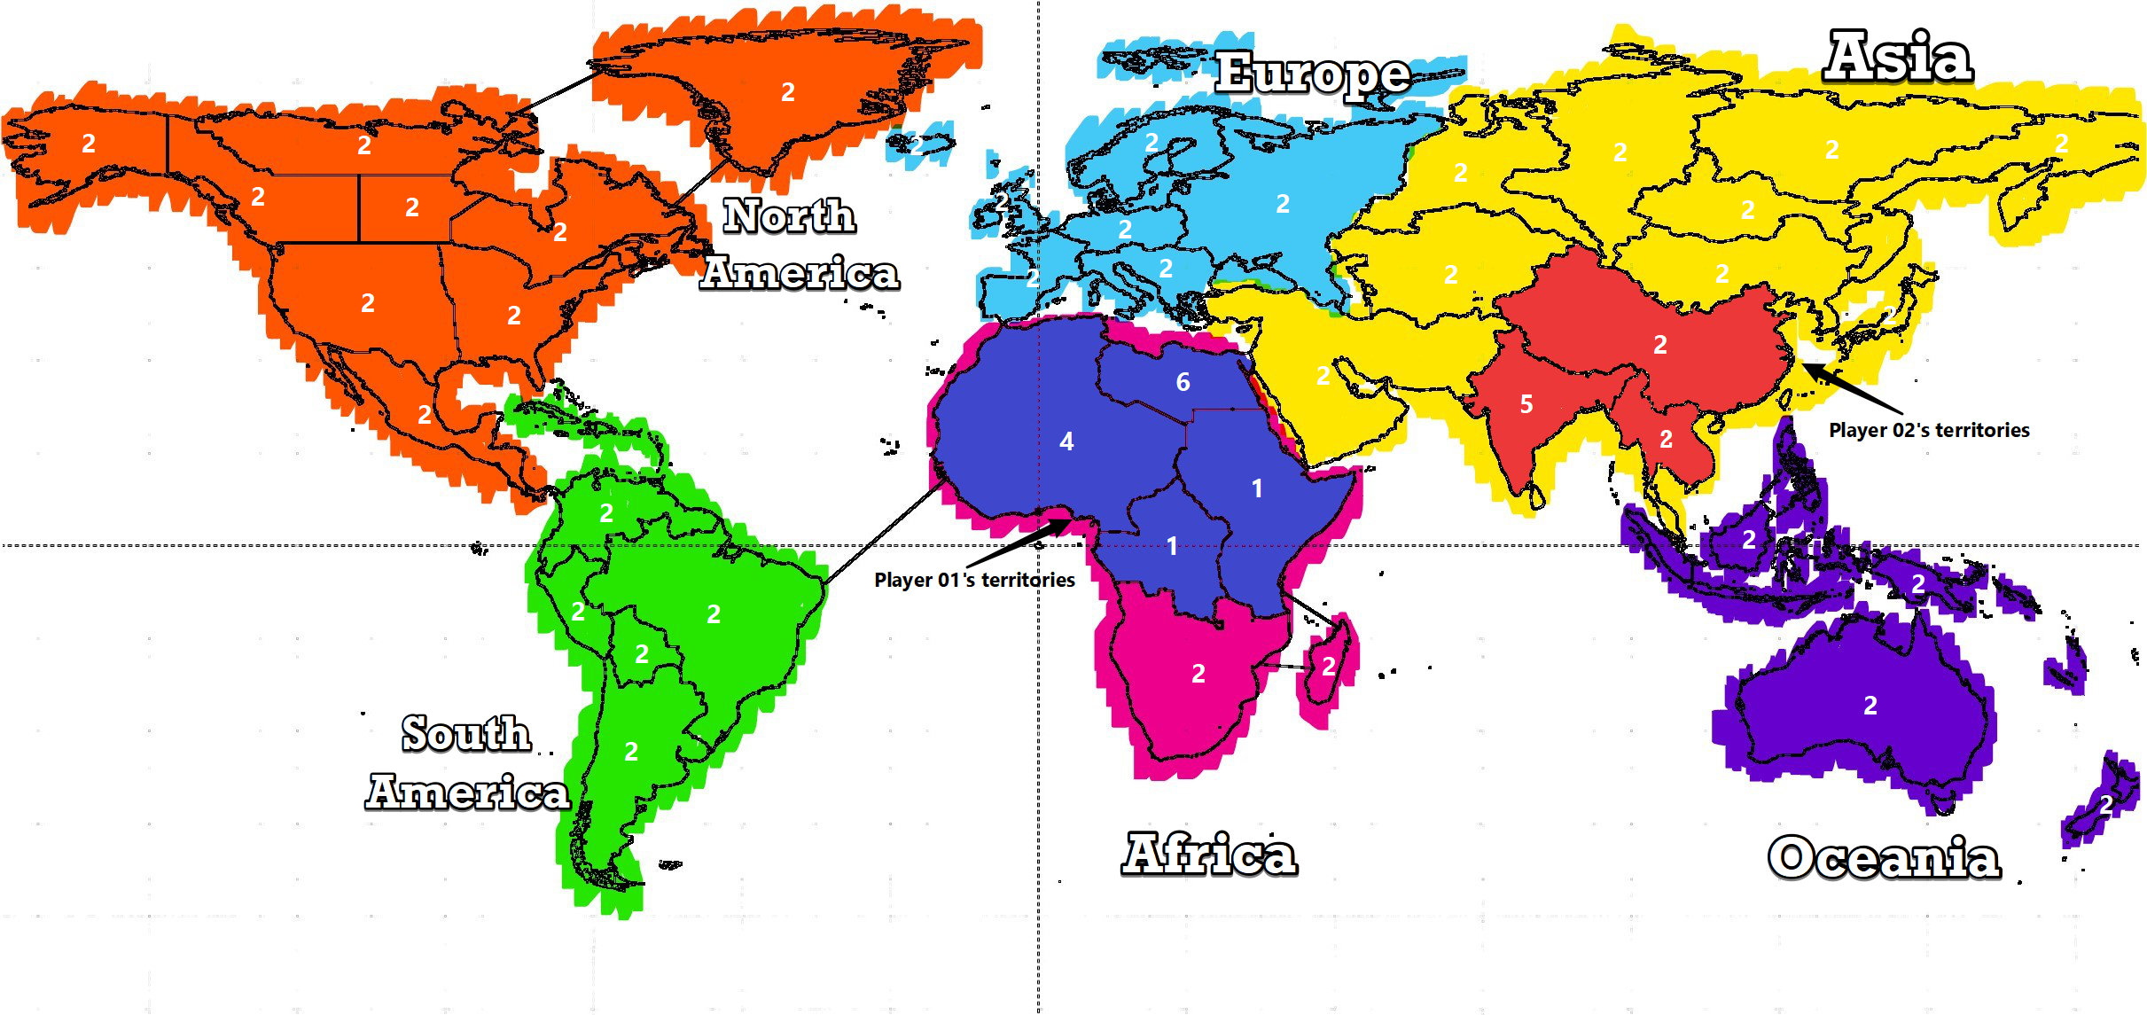

Figure 3 Game Map Design

### **4.4.1 Functional Components**

Functional components provide different functions to human players. As figure 4 shown, functional components will be composed by the topping bar, the recording panel and the player information panel.

* The topping bar includes four buttons and three text field on the top of the screen. From left to right, the two text-fields display the current turn number and the phase of the current turn respectively. The two buttons in the left allow the current human player to place her/his recruits or to attack nearby area and the rest two buttons allow the human player to end her/his turn or exit the game.
* The recording panel is vertically aligned at the bottom of the game screen. Actions of each player are recorded and then listed in the panel. In addition, there is a button at the top of the panel, which can hide whole its contents.
* The player information panel is hieratically aligned at the right of the screen. It shows all players’ representative colour, name, and number of recruits in each turn.

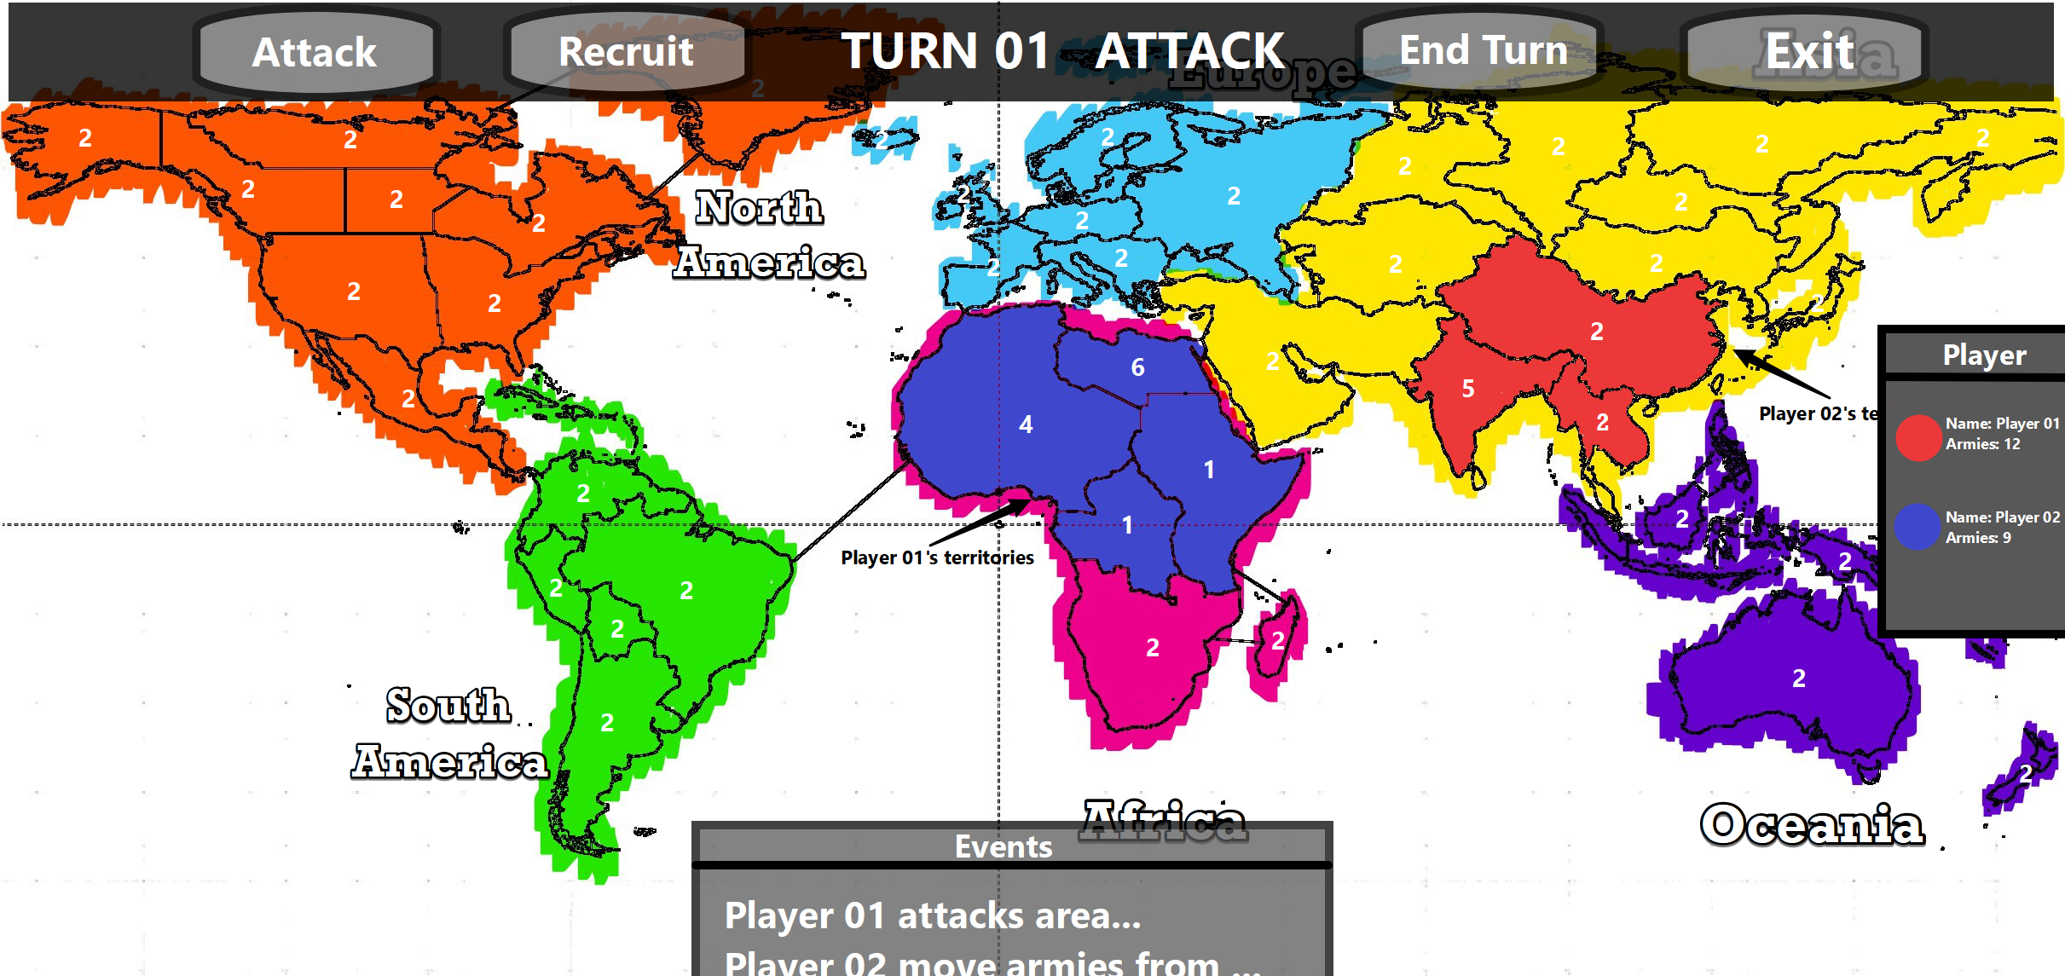

Figure 4 game interface design

**4.5 Components Design**

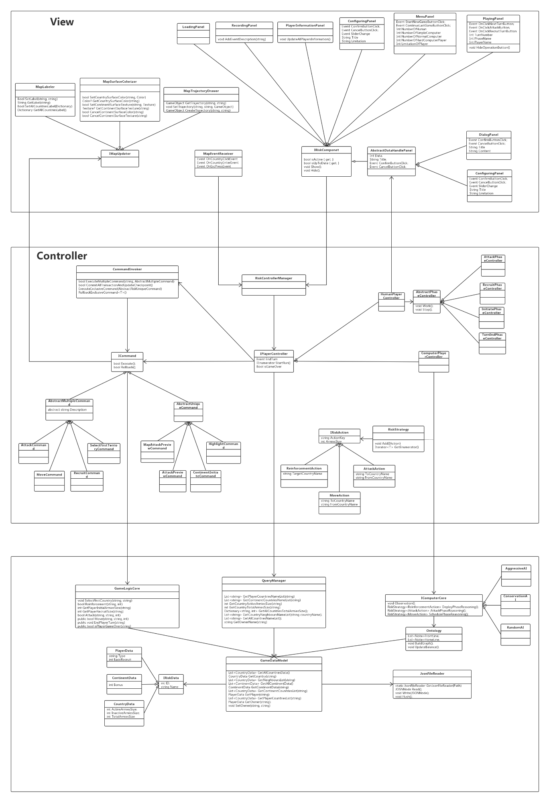

Figure 5 The class diagram

### **4.5.1 Classes in View**

In the game program, the view is composed of a set of encapsulations for the Unity GUI Components and WFPS Map package.

In term of WFPS map, The three classes, “MapAreaLabeler”, “MapSurfacePainter” and “MapTrajectoryDrawer” provide functions which will be used in the controller: the “MapAreaLabeler” wraps APIs which is used to change label and icon of each area on the map; the “MapSurfacePainter” allows the controller to colourise the surface of a specific area with a color or texture and the “MapTrajectoryDrawer” provides the function to draw a line between any two areas. Additionally, a class “MapEventReceiver” monitors all possible actions of a human player and generate matching events then send them to correct places.

Regarding the Unity GUI, they are a set of predefined functions attached in the Unity engine, which is used to receive and response user’ behaviours. A class, which wraps a group of Unity GUI functions for a specific component in the game view, provides a way to operate the component. There are total 8 classes in the game view, which operate eight different UI components. These eight classes are “LoadingPanel”, “RecordingPanel”, “PlayerInformationPanel”, “ConfiguringPanel”, “MenuPanel”, “PlayingPanel”, “DialogPanel” and “ConfiguringPanel”. In addition, an interface named “IRiskComponent” specifies the actions of these classes.

### **4.5.2 Classes in Controller**

In the controller part, the events generated from the view parts will be delivery to matching player controller and the class named “RiskControllerManager” manages all these player controllers. It also handles how to distribute a game turn of a player, because each player controller will deal with events received from the game view or updates the game view, at only the player own game turn.

The “HumanPlayerController” handles human player’s actions and it consists of a set of phase controllers due to the game program needs to react differently to the same action in different game phase. There is an abstract class named “AbstractPhaseController” which specifies functions of a phase class and there are four classes implementing this abstract class, namely, “IntiatePhaseController”, “RecruitPhaseController”, “AttackPhaseController” and “TurnEndPhaseController”. These classes are controls by the human controller and handle events from view when the player selects the first territory; deploys recruits; attacks other players’ territory or end her/his current game turn.

The “ComputerPlayerController” reasons a strategy basing on current condition and executes it in its turn. The computer player relies on the AI core to generate their strategy in each turn and the efficiency of the AI core decides which level a computer player belongs. However, the AI core is a part of the game model, the reasoning can only produce in the game model. The result of reasoning will be stored in the “RiskStrategy” and then, be sent to the computer player. The “RiskStrategy” is the container of the “IRiskAction” which include an instruction to the computer player. The “IRiskAction” is interface and it is implemented by “ReinforcementAction”, “MoveAction” and “AttackAction”.

To reduce the possible code duplication for updating the game mode and view, the command system is introduced in the game program. All updates for the game and view are implemented through the class “CommandInvoker” and a set of specific commands. The class “CommandInvoker” will execute all commands received and a command wraps all thing needed to do for updates. The interface “ICommand” describes the public interface for a command, in addition, there are two different kinds of command namely, “AbstractMultipleCommand” and “AbstractUniqueCommand”. “AbstractMultipleCommand” describes common functions for a command which can exist plural instances in the game. However, the class extending “AbstractUniqueCommand” can only have one instance in the game and the previous instance (if exist), it will be rollbacked. The classes “AttackCommand”, “MoveCommand”, “RecruitCommand” and “SelectFirstTerritoryCommand” implement “AbstractMultipleCommand” and the classes “MapAttackPreviewCommand”, “AreaHighlightCommand”, “ContinentInitiate-Command” and “MapInitiateCommand” implement “AbstractUniqueCommand.

### **4.5.3 Classes in Model**

The model part of the game program needs to read data from the local file to constructs a game data model which stores the data such as the geography relations of different areas, the territories and armies of each player, etc.

The “QueryManager” receives queries from the controller part and then searches possible result from the game model, after that it replies to these queries with data as exact as possible. It allows querying the data about the army’s size and owner of a specific area, all territories of certain player or neighbours of an area.

Compared with “QueryManager”, the “GameLogicCore” does not generate any return value after receiving a message from the controller part, because, it only changes the data in the data model. It provides the function to calculate the result of a battle and the size of recruit for each player.

The “GameDataModel” stores all data related to the game include the “PlayerData”, “ContinentData” and “CoutryData” and it also stores the relation of these data. The abstract class “IRiskData” specifies the characters of these data. The “PlayerData” class records the information of a player such as her/his id, name, the size of armies and territories. The “ContinentData” class represents a specified area on the map. The class includes the name of the continent, the manpower boon when a player has occupied the continent. The “AreaData” class represents a minimum geographic unit of the game. The class records a list of its nearby area names, the number of recruits generated in each turn and size of the armies on an area.

The “IComputerCore” is an interface for the AI core, which generates a strategy for the computer player. To produce a strategy, the computer player core will first collect information of current condition and then, generate a set of actions for reinforcement, attack and schedule armies basing on this collected information, after that produce a strategy. The “RandomAI”, “AggressiveAI” and the “ConservationAI” implements the “IComputerCore” class respectively.

An instance of the “ComputerPlayerOntology” will be created after the AI core collects enough information about the current condition. It builds a topology about the player’s territory and calculates the lack size of armies in areas which are adjacent to the enemy’s territory.

## **4.6 AI Activity Diagram**

In each player’s game turn, the player first deploys their recruits, and then attacks enemies, after that move armies to fortify the frontline of her/his territories. So, an AI player shall be able to produce all these actions through its reasoning. In addition, it shall also be able to observe current conditions of the environment (the game board), which provide enough information to execute reasoning. The sequence diagram below illustrates how messages exchange between computer player controller and model to generate these actions.

Before reasoning, the computer player controller (in controller part) will require the computer player core (in model part) to observe the game board to collect information such as its territories, armies’ size and enemies. Then, the computer player core will constitute an “ontology” based on the information from observation. After that, a strategy including a series of actions will be generated and delivered to the computer player controller. Finally, the controller will execute all actions in the strategy.

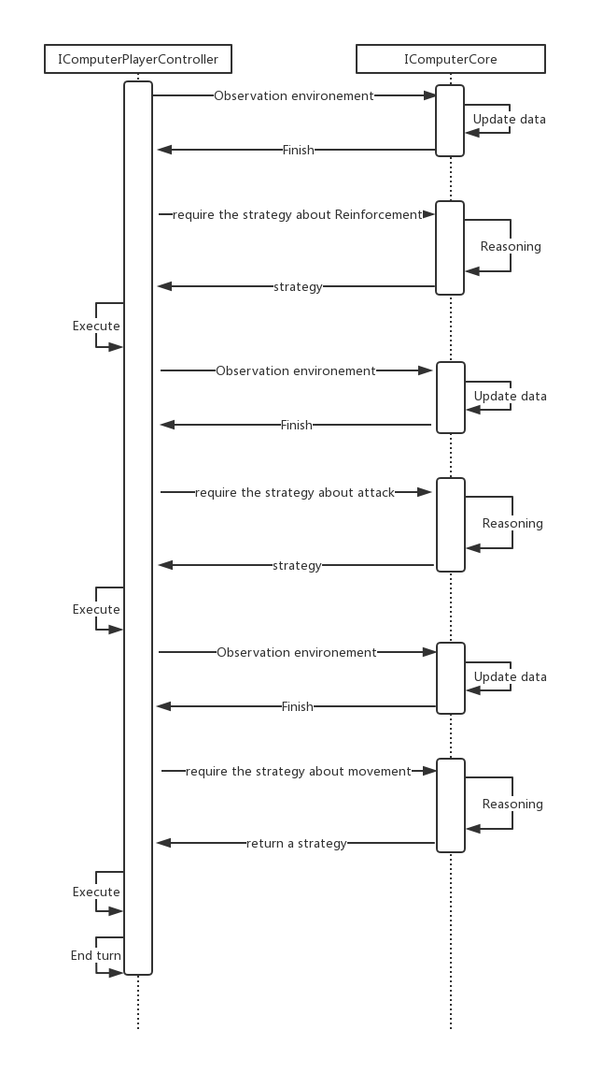

Figure Sequence Diagram for Computer player controller and model

**4.7 Data structure Design**

### **4.7.1 RelationMatrix**

The “RelationMatrix” is an implementation for the matrix with only entries from the Boolean domain {0,1} namely, relation matrix or binary matrix[17][18]. The pseudocode below describes possible functions and members in the “RelationMatrix”. The two dimensions byte array named “matrixCore” stores the value in each row and column of the matrix, in addition, two functions “SetRelation” and “GetRelation” allows to read and write these values.

class RelationMatrix {

byte[][] matrixCore

void SetRelation(int row, int column, bool value){

matrixCore[row][column] := value? 1:0

}

bool GetRelation(int row, int column){

return matrixCore[row][column]

}

}

Pseudocode 01: the pseudocode of the relation matrix

The class stores the binary relation between different game model data. In the project, the class is used as an adjacency matrix to record the neighbour-relation between two areas on the map. In addition, it also records the ownership between player and area, and the relation between area and continent.

### **4.7.2 PriorityOrderedList**

The “PriorityOrderedList” is a container class and all elements stored in the class will be sorted by a predefined integer parameter named priority. Therefore, the larger the priority is, the more front the element is in.

The pseudocode below describes possible functions and members in “PriorityOrderedList”. The List “listCore” stores all items and their priority. The function “Add” allows inserting a new item into the container and “GetElement” provides a method to retrieve data in there.

class PriorityOrderedList<T> {

List<(T, int)> listCore;

void Add(T newElement, int atPriority){

Use binary search to find out index of the element;

listCore.Insert(index, (newElement, atPriority));

}

T GetElement(int atPriority){

Use binary search to find out index of the element;

return listCore[index]

}

}

Pseudocode 02: the pseudocode of PriorityOrderList

In the class “MapSurfacePainter”, the colour on each area’s surface may alter at some condition, and then recover back to the previous colour. Therefore, it requires the class “MapSurfacePainter” to record the colours which were on each area surface. The “PriorityOrderedList” provides a method to implement the requirement and reduces the complexity of “MapSurfacePainter”.

### **4.7.3 GameStrategy**

The class “GameStrategy” is the container for the message between the AI core and computer player controller. The similar actions stored in the class will be merged.

The pseudocode below describes possible functions and members in class “GameStrategy”. All actions are stored in the list “strategyCore”. In addition, the class only provides the method “Add” to add new actions and method “GetEnumerator” to implement the Iterable interface.

class RiskStrategy<T>: IEnumerable<T> where T:IRiskAction

List<T> strategyCore;

void Add(T newAction){

compares with each other actions;

if find any similar action,

mergeing the two actions;

else

strategyCore.Add(newAction);

}

IEnumerator<T> GetEnumerator() {

return strategyCore.Values.GetEnumerator();

}

}

Pseudocode 02: the pseudocode of PriorityOrderList

### **4.7.4 BalanceGraph and BalanceNode**

The class “BalanceGraph” and “BalanceNode” are implementation for an abstract data structure named. “Undirected Graph” [19] and its node.

The diagram below describes a model of the data structure, “BalanceGraph”. In the diagram, circles and edges express instances of “BalanceNode” and neighbour-relations between these nodes. In addition, the number on nodes means the depth of a node which is called “Level” in the class. To constitute a balance-graph, the shallowest nodes (whose level equal 0) shall be predefined and the levels of other nodes shall equal to the smallest number in neighbours’ level plus one. In addition, a special algorithm will calculate the balance for each node. These nodes and edges consist of a balance graph.

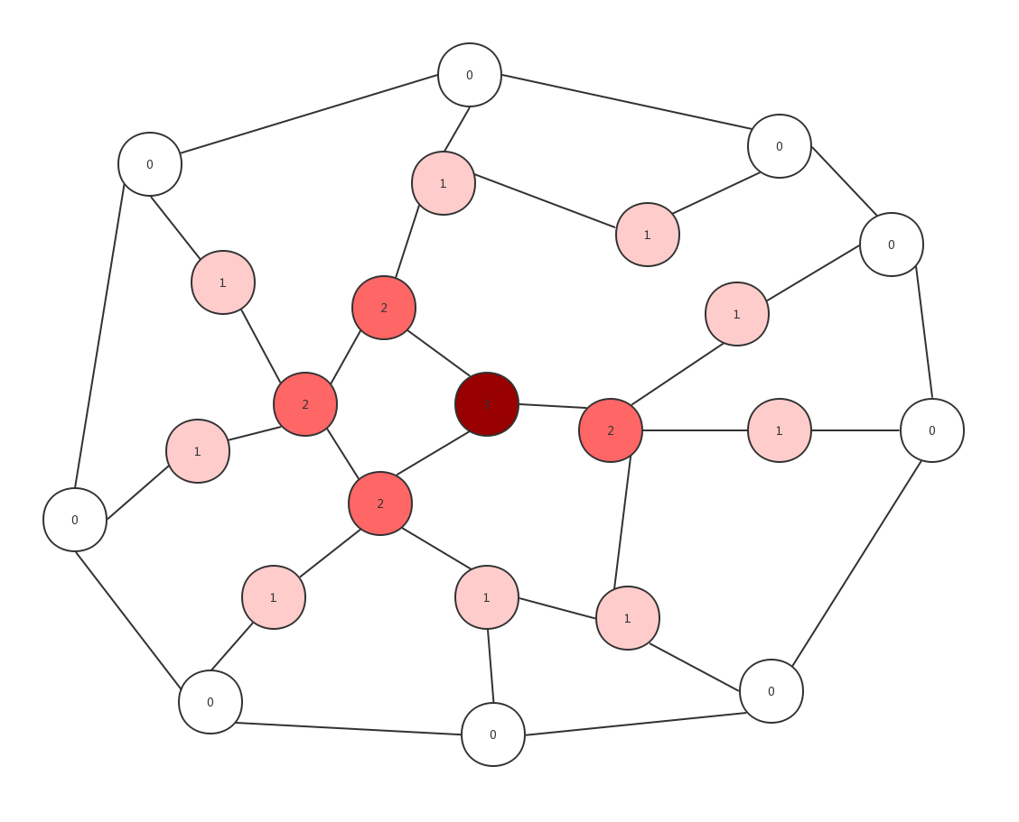

Figure Example of BalanceGraph

In the project, this data structure is used to store the essential data in AI core such as the computer player’s territories and enemies. In addition, a distributed algorithm is implemented in the data structure, which will calculate the size of armies each node required for fortifying.

The pseudocode below describes public functions and members in two classes. The “shallowestNodeList” is used to store the nodes whose level equal 0. The function “UpdateBalance” shall calculate the balance for each node through a predefined algorithm and “GetBalance” shall return the balance value of a specified node. In addition, “Get” and “Add” provide an interface to write an read the data store in the graph.

class BalanceGraph<T> where T:IRiskData {

List<BalanceNode<T>> shallowestNodeList;

bool UpdateBalance(){…}

int GetBalance(T ofItem){…}

List<T> Get(int atlevel){…}

void Add(T Item, List<T> neighbourList){…}

private class BalanceNode<T> where T:IRiskData {

int CurrentLevel { get; private set; }

int Balance { get; private set; }

T dataCore { get; }

List<BalanceNode<T>> NeighbourNodes

}

}

Pseudocode 03: the pseudocode of Balance Graph

**4.8 Algorithm Design**

### **4.8.1 Binary Searching**

In the data structure “PriorityOrderedList”, it is essential to traverse the whole list in some methods. Because the data stored in “PriorityOrderedList” are sorted by their predefined priority, the binary searching algorithm can be used to reduce the complexity of some operations in the data structure.

function binary_search(A, n, T):

L: = 0

R: = n

while L < R:

m: = floor((L + R) / 2)

if A[m] <= T:

L: = m + 1

else :

R: = m

return L - 1

Pseudocode 04: the pseudocode for Binary Search [19]

### **4.8.2** **FloodMin Algorithm**

In the project, the FloodMin algorithm is used to build or update the data structure “BalanceGraph”. The design and implementation of the FloodMin algorithm based on the FloodMax algorithm introduced on Module COMP212 Distributed system.

var myLevel := max_int; // node current level   
var receiveLevels := new List<Level>   
var diameter := diameter of the graph  
if (round = 1) then  
 send own level to all neighbours;  
else  
 receiveLevels := receiving levels from neighbours;  
if max(receiveLevels) < myLevel - 1   
 myLevel := max(receiveLevels) - 1  
 newInfo := true  
else   
 newInfo := false  
if round ≤ diameter and newInfoi = true then  
 send myLevel to all neighbours  
else if round = diameter + 1 then   
 return;

Pseudocode 05: the pseudocode of FloodMin [5]

### **4.8.3 Balance Calculating Algorithm**

The Balance Calculation algorithm is used to estimate the size of armies for each territory required to fortify, which are called balance in the project. In both reinforcement and fortification stage, the AI core will generate the best strategies based on these data.

foreach node whose level equal 0

node.Balance := area.armiesSize;

foreach nearby enemies’ territory

node.Balance -= the size of armies on nearby enemy territory;

foreach exist level in the player’s territories

foreach node whose level equal current Level  
 node.Balance := area.armiesSize;

foreach neighbour node whose level is less than current Level

if neighbourNode.Balance < 0  
 node.Balance -= neighbourNode.Balance;

Pseudocode 06: the pseudocode of Balance Calculating Algorithm

**4.9 Test Design**

As described in the specification document, the project will use the object-oriented testing to test the program and will strictly follow a top-down integrate testing process, namely, operation test, class test, cluster test, system test.

### **4.9.1 System Test Design**

At first, the system test shall check the integration of the whole system. The black-box test will be used to implement the system test. Specifically, it shall include tests below:

Set the number and type of computer game player;

Click different game map areas;

Deploys recruits;

Attack others player’s territory;

Move armies in test player’s territories.

Check scenes for winning or losing the game

### **4.9.2 Cluster Test**

Second, the cluster test shall check the message communication between different game components. In the project, the test can be done through the Unity Debug package, which provides a set of functions to check variables in the game program. In addition, it shall include tests below:

Check the communication between the game view and game controller;

Check the communication between the game controller and game model;

### **4.9.3 Unit Test**

In the class and operation test, the public fields of the critical classes will be tested. Unit Test tool for the C#, NUnit will be used to test methods provided in the class map painter, map labeler, map trajectory maker and the game model. Because almost all controllers directly communicate with both game view and game model, there is not a class test and operation test on the game controller. Specially, it shall include:

Check the correction of the data stored in the RiskDataModel;

Check the functions in the RiskDataModel;

Check the functions in MapSurfacePainter;

Check the functions in MapTrajectoryMaker;

Check the functions in MapLabeler.

**4.10 Evaluation Design**

### **4.10.1 Self-evaluation**

In the project, the programmer will be required to evaluate the game quality by “functional points”. In the function point evaluation, the game will be divided into a series of functions in different aspects and each aspect will be allocated a weight. The programmer needs to count the number of finished requirements in different aspects to calculate the final value of the game. Table 02 below describes different aspects of function point and their weight.

|  |  |  |  |  |  |  |  |
| --- | --- | --- | --- | --- | --- | --- | --- |
| **Function** | **Simple** | | **Normal** | | **Hard** | | **Total** |
| **Point** | **Num** | **Point** | **Num** | **Point** | **Num** |
| Game logic | 2 |  | 3 |  | 5 |  |  |
| User interface | 1 |  | 2 |  | 3 |  |  |
| Game Controller | 2 |  | 3 |  | 4 |  |  |
| Artificial Intelligence | 3 |  | 5 |  | 8 |  |  |

*Table 01: The table for the function points*

The game logic, user interface, game controller and artificial system respectively represent the function in the game model, game controller and the artificial intelligence system. The simple, normal and hard represent the complexity of these function.

Additionally, the programmer will use the functional and non-functional requirements as the criteria to compare the risk game online such as PoloRisk and WarGameRisk.

|  |  |  |  |
| --- | --- | --- | --- |
| **Function** | **Marks (0 ~ 5)** | | |
| **The project** | **Warzone** | **PoloRisk** |
| Is the game online available? |  |  |  |
| Is there a visual user interface? |  |  |  |
| Can the player attack an enemy? |  |  |  |
| Can the player move the army? |  |  |  |
| Can the player deploy recruit? |  |  |  |
| Does the game provide multiple game model? |  |  |  |
| Does the game provide different kinds of computer player? |  |  |  |

*Table 02: The table for the criteria*

### **4.10.2 3rd party Evaluation**

In this part, the project will design a survey to collect feedback from the player. In addition, the project will strictly follow the requirements in the “Computer Science Student project 3rd party Evaluation Procedure” [5]

|  |  |
| --- | --- |
| Questionnaire | Marks (-5~5) |
| How likely is it that you would play this game on your computer or smartphone? |  |
| Is the game user-friendly? |  |
| Is the UI well-designed? |  |

*Table 03: The table for the Questionnaire*

### **4.10.3 AI Evaluation**

The game intelligent agent will be evaluated through an analysis of the result of the “computer versus computer” game. The “Evaluation Function”, such as the heuristic evaluation function or the static evaluation function, shall be used to produce the score for each player.

# **5. Realisation**

As part 4: Revised Design described, the program completely follows the MVC architecture design pattern, so the implementation for the three parts can be parallel.

Although the previous design has been changed during the implementation, the process is still divided into three stages. The three stages respectively focus on the view, controller and model of the game.

Therefore, the document will describe the realisation of the program through “Implementation of View”, “Implementation of Controller” and “Implementation of Model”.

### **5.1 Implementation of View**

### **5.1.1 Game Map and UI Components**

In this project, a series of library and assets, including UnityEngine library WFPS and Unity UI system GUI, is used to implement the game interface.

WFPS is a UnityEngine library released on UnityStore, which provide a 2D world map and a set of basic functions to operate the map. The image below shows the default world map generated. It is noticeable that there are too many details in the map to be the game map of Risk.



Figure Default WFPS game map

Therefore, the game map is modified to remove the redundant details. Figure 9 shows the final game map. Compared with the default world map provided by WFPS, it merges multiple areas into one and removes redundant geographic details on the map. In addition, the continents on the map are covered by different textures. It makes the human player be able to identify different continents easier.

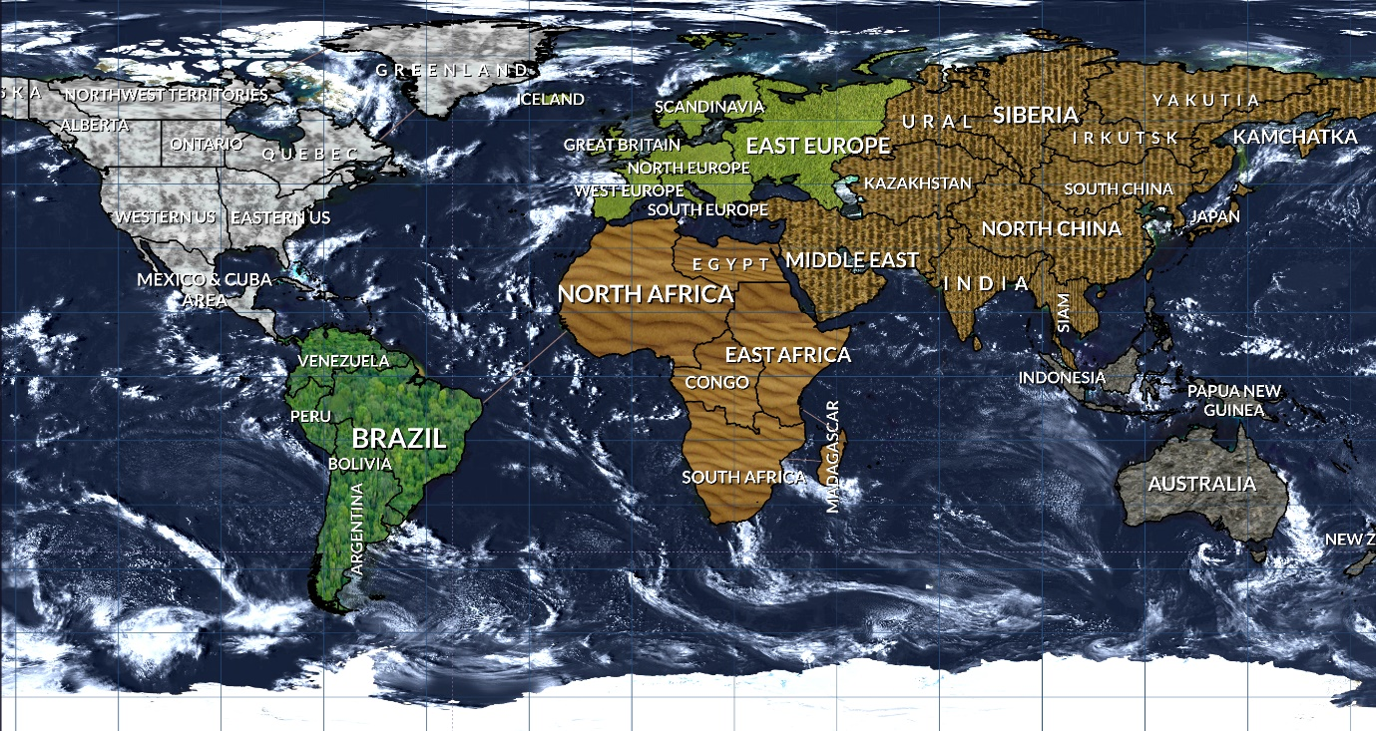

Figure 9 Implementation of the game map

In term of game interface components, all game components in the game, such as the button, panel and menu are developed through the Unity GUI. Unity GUI is the UI system in UnityEngine, which provides a set of tools to arrange the position and style of components in the user interface [20]. Figure 10 below presents a complete game interface. As the section “4.4.1 Functional Components” described, the game components consist of the top panel, recording panel and player panel. In addition, most of the components follow the design in the section except the top panel where there is an additional text-field to display the name of the current player.

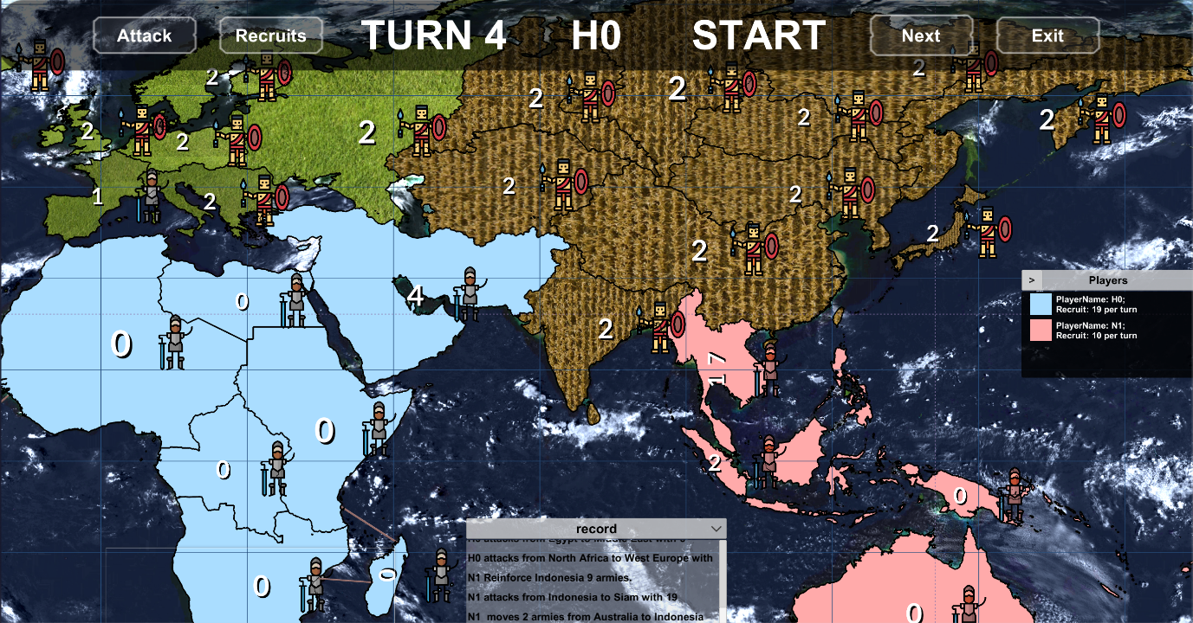

Figure 9 Implementation of the game map

### **5.1.2 Encapsulation to Unity GUI and WFPS**

The encapsulation can reduce the dependence between the program with outside libraries so that, it improves the reusability of the game program. In the project, it is the core for game view implementation to wrap two unity libraries, the WFPS and Unity GUI.

Regarding the encapsulation of the GUI, it provides the controller part the possibility to operate the game components such as the dialogue, the loading panel and the game setting menu. In the project, there are total 8 classes which are used to encapsulate the Unity GUI and there is a predefined interface for these class. Code 01 and Code 02 below show the C# code of the interface and implementation for the loading panel. The boolean variables “isActive” is true when the component is displayed on the screen and “isUpToDate” is true until game over. The two methods “Show” and “Hide” controls whether a game component is displayed on the screen or not.

public interface IRiskViewPanel {  
 bool isActive { get; }  
 bool isUpToDate { get; }

void Show();  
 void Hide();  
}

Code 01: the interface of wrap class

public class RiskLoadingPanel :IRiskViewPanel {  
 public bool isActive => core.activeSelf;  
 public bool isUpToDate => core != null;  
 private readonly GameObject core;  
   
 public RiskLoadingPanel(GameObject panelCore) {  
 core = panelCore;  
 }  
 public void Show() {  
 core.SetActive(true);  
 }  
 public void Hide() {  
 core.SetActive(false);  
 }  
}

Code 02: loading pane class

In term of the Game map view, there are four classes which encapsulate all functions of the library WPFS used in the project. The four classes are the “MapAreaLabeler”, the “MapSurfacePainter”, the “MapTrajectoryMaker” and the “MapEventReceiver”. The previous three classes provide a set of functions to update the map view and the last one monitor human player’s actions, such as moving the pointer into or directly clicking on a specific area, then delivery an event to some matching controller.

Code 03 and Code 04 respectively are the code-sections in WPFS used to colourise surface of the specific area and the encapsulated method in the map colouriser.

var decorator = mapView.decorator.GetAreaDecorator(continent, areaName);

decorator.fillColor = Color.white;

Code 03: The code-sections in WPFS used to colourise the surface of the specific area

private void updateAreaSurfaceColor(string name) {  
 var areaIndex = mapView.GetAreaIndex(name);  
 var area = mapView.countries[areaIndex];  
 var decorator = mapView.decorator.GetAreaDecorator(area.continent, area.name);  
 var priorityStack = areaColorDictionary[name];  
 var highestPriorityColor = priorityStack.GetHighestPriorityElement();

decorator.fillColor = (Color) highestPriorityColor;  
}

Code 04: the encapsulated method in the map colouriser

Code 05 and Code 06 respectively are the code-sections in WPFS used to draw a trajectory from an area to another area and the encapsulated method in the trajectory maker.

var newTrajectory = mapView.AddLine(  
 start: start,  
 end: end,  
 color: color,  
 arcElevation: arc,  
 duration: 0.5f,  
 lineWidth: 0.5f,  
 fadeOutAfter: 0.0f  
);

Code 05: the code-sections in WPFS used to draw a trajectory

public GameObject CreateTrajectory(string fromAreaName, string toAreaName, Color color, float arc) {  
 int startArea = mapView.GetArea(fromAreaName);  
 int endArea = mapView.GetArea(toAreaName);   
 var newTrajectory = mapView.AddLine(  
 start: startArea.centre, end: endArea.centre, color: color,

arcElevation: arc, duration: 0.5f, lineWidth: 0.5f, fadeOutAfter: 0.0f  
 );  
 newTrajectory.SetActive(false);  
 return newTrajectory;  
}

Code 06: the encapsulated method in the trajectory maker

Code 07 and Code 08 respectively are the code-sections in WPFS used to set the label of a specific area and the encapsulated method in the map labeler.

var areaDecorator = mapView.decorator.GetAreaDecorator(continent, areaName);

areaDecorator.customLabel = labelStr;

Code 07: the code-sections in WPFS used to set the label

public void SetLabel(string onAreaName, string labelStr) {  
 var area = mapView.GetArea(onAreaName);  
 var notification = new GameObject();  
 var areaDecorator = mapView.decorator.GetAreaDecorator(area.continent,onAreaName);  
 areaDecorator.customLabel = labelStr;

areaTextLabelDictionary[onAreaName] = labelStr; //Record the value of text label  
}

Code 08: the encapsulated method in the labeler

Code 09 is the original events defined in WFPS, and Code 10 is the encapsulated events. Compared with the original version, these events are more suitable for the controller, because, it encapsulates the process to handle the specific parameters.

public delegate void OnCountryEvent(int countryIndex, int regionIndex);

public event OnCountryEvent OnCountryEnter;  
public event OnCountryEvent OnCountryClick;

Code 09: original events in WFPS

public delegate void mapInteractEventDelegate(string areaName);  
public event mapInteractEventDelegate OnAreaClickEvent;  
public event mapInteractEventDelegate OnAreaEnterEvent;

public MapEvent() {  
 map.OnCountryClick += ClickOnArea;  
 map.OnCountryEnter += MoveOnArea;  
}

private void ClickOnArea(int areaIndex, int regionIndex) {  
 var areaName = WorldMap2D.instance.countries[areaIndex].name;  
 OnAreaClickEvent?.Invoke(areaName);  
}

private void MoveOnArea(int areaIndex, int regionIndex) {  
 var areaName = WorldMap2D.instance.countries[areaIndex].name;  
 OnAreaEnterEvent?.Invoke(areaName);  
}

Code 10: Encapsulated events in the event receiver

### **5.1.4 Changes on View Design**

In the project, there are three different versions of the game view. The first one follows the original interface design in “specification and design document” (see Append 01). The second implementation implements the current interface design described in section 4.4 Interface Design. Compared with these two implementations, the final one extents design in the document to make it more user-friendly.

Figure 10 below is the implementation of the original interface design. In the implementation, there are too many areas on the map to as the game map. In addition, the boundary between two areas, the buttons and the text field on the top of the game view are not clear enough.



Figure 10 Game Interface version 01

And Figure 11 is the second version of the game interface. Compared with the previous design, interface version 2 reduce the areas on the map and re-layout interface components. However, after the demonstration, I realise that it may cause confusion that both continents and players territories are identified through different colours. Therefore, in the final implementation noticed in section 5.1.1, the different textures cover on each continent, instead of colours. In addition, some extension features such as army icon and highlight function are implemented in the final version.

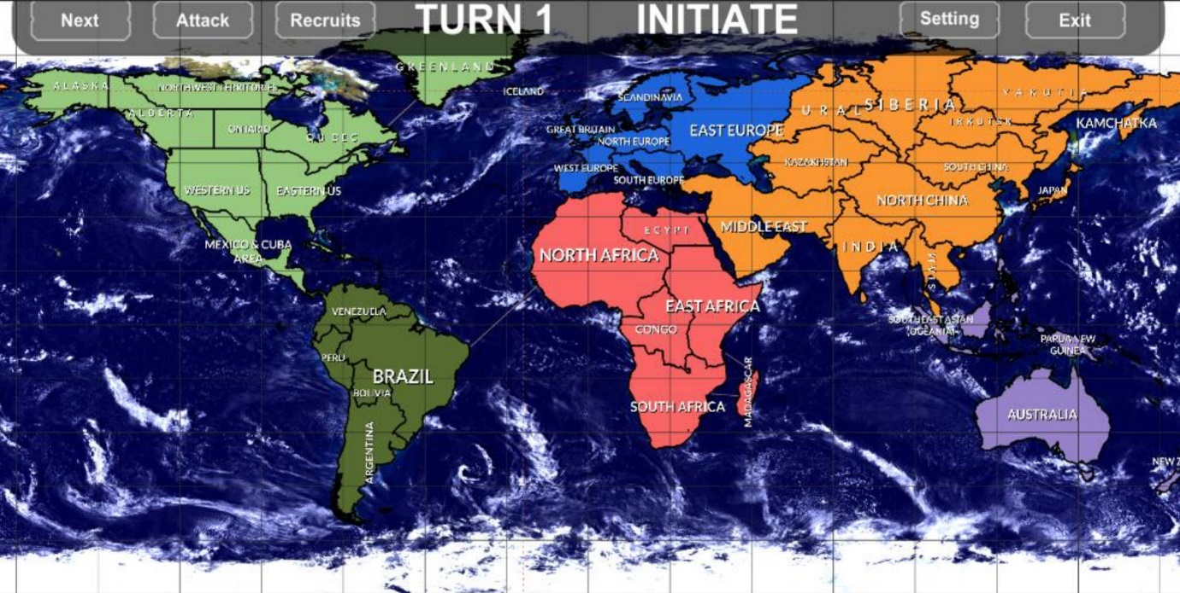

Figure 11 Game Interface version 02

### **5.1.5 Problems Encountered in the game view**

The main problem that occurs during the game view implementation, is how to implement the highlight functionality. The highlight functionality means when a player clicks one area, the area and all its adjacent areas will be highlighted. In addition, the human player can cancel the highlight any time she/he wants. Figure 12 shows the game map when the framing out area is highlighted. It clear to see that the clicked area will be red, and its adjacent areas will be grey when its highlighted.

The problem is how to recover the highlighted areas back to their previous colours or textures after human player cancels it.

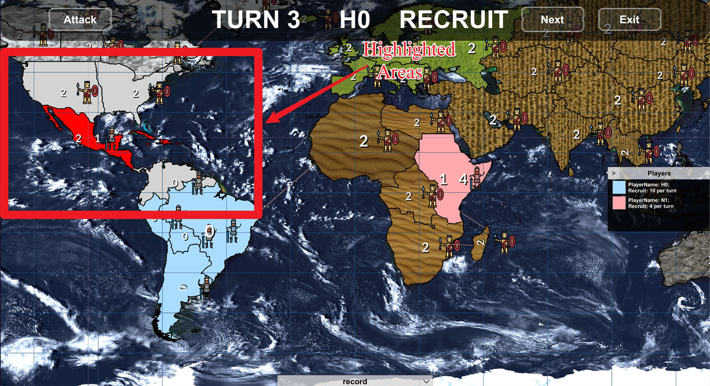

Figure 12 Game Interface version 02

To solve the problem, the data structure priority ordered list, which is described in the section “4.7.2 PriorityOrderedList” is implemented. Code 04 in section 5.1.1 shows how the data structure works in the map surface painter. The colours of each area hierarchically store in an independence instance of this data structure. The map surface painter will only paint the area surface the colour with the highest priority. Code 11 shows a part of the implementation for the priority ordered list.

class PriorityOrderedList<T> {

…  
 private readonly List<(T, int)> stackCore;  
  
 public void Add(T newElement, int atPriority) {  
 if (stackCore.Count == 0 || stackCore.Last().priority < atPriority) {  
 stackCore.Add((newElement, atPriority));  
 return;  
 }

var index= BinarySearch(atPriority);

stackCore.Insert(index, (newElement,atPriority));  
 }  
  
 public (T,int)? GetHighestPriorityElement() {  
 if (stackCore.Count == 0)   
 return null;  
 else

return stackCore.Last();  
 }  
}

Code 11: code sections of Priority Ordered List

In addition, how to access the instance of the game interface components are another problem encountered in this part. These components (such as the dialogue, the menu and configuration panel) are used in many controller classes. Based on the lecture content of COMP319 [21], there are three different methods to share an object between different classes:

* Unity APIs
* Global Static Variables
* Singleton Pattern
* Abstract Factory Pattern

In all four methods, the first one will cause the code duplication. The second one and third one break the conception of object-oriented and the open-closed principle respectively [21]. Therefore, an abstract factory is decided as the solution to the problem. Code 12 is the code section for the implementation of the abstract factory, “RiskViewSearcher”. In the class, the method “GetComponentByName” uses C# reflection mechanism and generics to access the components object. It follows the dependency inversion principle so that, the method can access any object of a class which extends the IRiskComponent.

public class **RiskViewSearcher**: MonoBehaviour {

…  
 private GameObject **GameUI**;  
 private Dictionary<Type, IRiskViewPanel> componentCache;  
  
 public T GetComponentByName<T>(string componentName) where T : IRiskViewPanel {  
 if (componentCache.ContainsKey(typeof(T))) {  
 return (T) componentCache[typeof(T)];  
 }  
  
 var componentCore = FindChildObjectByName(fromObject: GameUI, componentName);  
 var parameter = new object[] {componentCore};  
 componentCache[typeof(T)] = (T) Activator.CreateInstance(typeof(T), parameter);  
 return (T) componentCache[typeof(T)];  
 }

private GameObject FindChildObjectByName(GameObject fromObject, string objectName) {  
 var gameObjectNumber = fromObject.transform.childCount;  
 for (var index = 0; index < gameObjectNumber; index++) {  
 var anyChildrenObject = fromObject.transform.GetChild(index).gameObject;  
 if (anyChildrenObject.name == objectName) return anyChildrenObject;  
 }  
 return null;  
 }  
}

Code 12: code section in the RiskViewSearcher

## **5.2 Implementation of Controller**

### **5.2.1 Player Controller**

“Player controller” is a communication channel between the game view and model. The abstract class named “AbstractRiskPlayerController” is a superclass of all player controller. Code 11 below shows the implementation of the abstract class. There are four protected abstract methods, namely “StartInitiateCore”, “StartRunCore”, “EndTurnCore”, “IsGameOver” and “IsInitiated”. All abstract methods are used in a public method “StartRun” which will be invoked when a player’s game turn starts. In addition, there is an abstract event named “EndTurnEvent” which is generated when the player ends own game turn. All player class just need to implement these abstract methods and event.

public abstract class AbstractPlayerController {  
 public delegate void PlayerEventDelegate();  
 public abstract event PlayerEventDelegate EndTurnEvent;  
  
 public void StartRun() {  
 if (!IsInitiated()) // if the game player does not finish initiation  
 StartInitiateCore();

else if (IsGameOver()) // if the game is over  
 EndTurnCore();  
 else   
 StartRunCore();  
 }  
 protected abstract bool IsInitiated()  
 protected abstract bool IsGameOver();  
 protected abstract void StartRunCore();  
 protected abstract void StartInitiateCore();  
 protected abstract void EndTurnCore();  
}

Code 13: code section of Abstract Player Controller

For a human player, the player controller interprets her/his behaviour and then, invokes different functions in the game model to handle it after that, the player controller deliveries the result to game view. In the project, there is one human player controller, “RiskHumanPlayerController”. Code 14 is the code section for the human player controller.

protected override IEnumerator StartInitiateCore() {  
 controllerDictionary[GamePhase.INITIATE] = new InitiateMapInteractionController();;  
 controllerDictionary[GamePhase.START] = new TurnStartPhaseController();  
 controllerDictionary[GamePhase.RECRUIT] = new RecruitMapInteractionController();  
 controllerDictionary[GamePhase.ATTACK] = new AttackMapInteractionController();  
 controllerDictionary[GamePhase.END] = new TurnEndPhaseController();  
 SetCurrentController(GamePhase.INITIATE);  
}

protected override IEnumerator StartRunCore() {  
 gameCanvas.Show();  
 gameCanvas.PlayerText = playerName;  
 gameCanvas.OnClickNextTurnButton += EndTurn;  
 gameCanvas.OnClickRecruitTurnButton += StartRecruitPhase;  
 gameCanvas.OnClickAttackButton += StartAttackPhase;  
 SetCurrentController(GamePhase.START);  
}

private void EndInitiate() {  
 SetCurrentController(GamePhase.END);  
 EndTurnEvent?.Invoke();  
}

private void SetCurrentController(GamePhase atPhase) {  
 currentMapController?.Stop();  
 currentMapController = controllerDictionary[atPhase];  
 currentMapController.Work();  
 gameCanvas.PhaseText = atPhase.ToString();  
}

Code 14: code core of Human Player Controller

For the computer player, the player controller directly sends the message to AI core to produce a strategy based on current conditions after that, the controller also sends results to the game view. In the project, there are 3 computer player controllers namely, “RiskAggressiveComputerPlayer”, “RiskConservationComputerPlayer” and “RiskRandomComputerPlayer”. Code 15 is the code section for aggressive computer player controller.

private AggressiveComputerCore aiCore;

protected override void StartInitiateCore() {  
 aiCore.Observation();  
 var initiateStrategy = aiCore.DeployPhaseReasoning();

execute(initiateStrategy);

EndTurnEvent?.Invoke();  
}

protected override void StartRunCore() {  
 aiCore.Observation();//Recruit Phase  
 var recruitStrategy = aiCore.DeployPhaseReasoning();

execute(recruitStrategy);   
 aiCore.Observation();//Attack Phase

var attackStrategy = aiCore.AttackPhaseReasoning();

execute(attackStrategy);   
 aiCore.Observation();//Schedule Phase

var scheduleStrategy = aiCore.SchedulePhaseReasoning();

execute(scheduleStrategy);

EndTurnEvent?.Invoke();  
}

protected override void EndTurnCore() {  
 EndTurnEvent?.Invoke();  
}

private void Execute(RiskStrategy strategy){

var actionEnumerator = strategy.GetEnumerator();

while(actionEnumerator.MoveNext()) {  
 var action = actionEnumerator.Current;  
 var command = Command.buildFrom(action);  
 commandInvoker.ExecuteCommand(playerName, command);  
 }

}

Code 15: code section in computer Player Controller

### **5.2.2 Player Controller Manager**

“PlayerControlleManager” schedules all player’ game turn. When any player’s game turn finish, the player controller manager will notify next player’s controller to start next game turn. Code 16 below shows the code-section of the “RiskControllerManager”. The class directly communicates with an abstract player controller instead of a specific player controller class. It follows the dependency inversion principle.

public class **RiskControllerManager**: MonoBehaviour {

…

private int totalRunTimes;

private List<AbstractPlayerController> playerControllers;

private int currentTurn => totalRunTimes / playerControllers.Count;

private int currentPlayerIndex => totalRunTimes % playerControllers.Count;  
  
 private void MoveToNextPlayer() {  
 totalRunTimes += 1;  
 playerCanvas.TurnNumber = currentTurn;  
 playerIdentifyPanel.UpdateAllPlayers();  
 playerControllers[currentPlayerIndex].StartRun()  
 }

}

Code 16: code section of Player Controller Manager

### **5.2.3 Command and Invoker**

Command and Invoker are the implementations of the command pattern. In the project, Command provides both human and computer player controller a set of methods to update the game view and Invoker will execute these commands generated from the player controller. Code 14 and Code 15 below are the interface for all commands and implementation of Invoker.

interface IRiskCommand {  
 bool Execute();  
 bool Rollback();  
}

Code 17: code of ICommand

public class RiskCommandInvoker {

…

private readonly Dictionary<Type, AbstractRiskUniqueCommand> exclusiveCommandDictionary;

public bool ExecuteMultipleCommand (string playerName, AbstractRiskMultipleCommand command) {  
 if (command.Execute()) {  
 return true;  
 } else {  
 riskMultipleCommand.Rollback();  
 return false;  
 }  
 }

public bool AbortLastMultipleCommand() {  
 var transaction = multipleCommandDeque.Last();  
 multipleCommandDeque.RemoveLast();  
 return transaction.Rollback();  
 }

public bool ExecuteExclusiveCommand(AbstractRiskExclusiveCommand command) {  
 var type = command.GetType();  
 if(exclusiveCommandDictionary.ContainsKey(type))  
 exclusiveCommandDictionary[type].Rollback();  
 exclusiveCommandDictionary[type] = command;  
 return command.Execute();  
 }

public bool RollbackExclusiveCommand<T>() {  
 var type = typeof(T);  
 return exclusiveCommandDictionary.ContainsKey(type)  
 && exclusiveCommandDictionary[type].Rollback()  
 && exclusiveCommandDictionary.Remove(type);  
 }

}

Code 18: code section of Player Controller Manager

### **5.2.4 Changes on Controller Design**

The implementation of the controller part is completely different from the previous design and strictly follows the current design in section 4.5 Component Design. Figure 13 below is the controller part of the previous class diagram. Compared with the real program, the original design is simpler because it invokes the APIs provided by Unity library and implements a class “NotificationCentre” which send message directly to these unity scripts to update the game view. The previous design, however, causes a high-coupling program. In addition, it ignores how to implements the game turn and to handle different players’ actions.

In contrast, the current one reaches the requirement, high-coherence and low-coupling. Generally, in the game program, various player controllers handle different players actions; the player controller manager schedules the game turn and the command with its invoker update the game view.

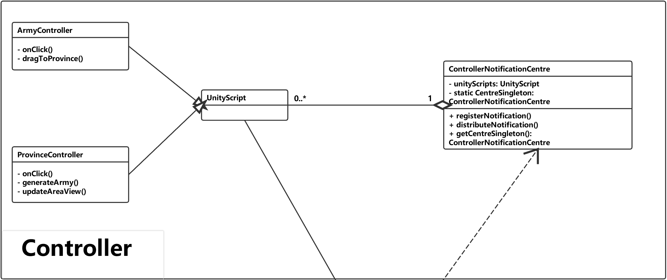

Figure 13 the controller part in the previous class diagram

### **5.2.5 Problems Encountered on the game controller**

In the human player controller, the game view needs a mechanism to response player same actions in different conditions, for example, if a player clicks own territory, it will be highlighted in the reinforcing phase but will not be highlighted in the initiating phase. So, the first problem is how to respond to the player’s same actions in different condition. There are two different ways to solve the problem.

* The first way is to implement a set of methods in a class, HumanPlayerController, to handle all possible actions of a human player. It may be able to solve the problem but, the class will break the single responsibility principle [21]. Because, it means the class needs to handle human players behaviours in at least three different game phases (such as, Initiating phase, Deploying phase, Attacking phase) and there are more than three different actions in each phase (such as, clicking certain area, moving the mouse pointer and pressing some button).
* The second one is to implements a set of classes to handle the player’s actions independently in different phases. It is used in the project and Code 15 in section 5.2.1 describes how it works. When a player changes from a phase to another one, “HumanPlayerController” will change the value of the variable named phaseCore and will handle human player’s action through the variable, instead of the different methods. There is an abstract class named “AbstractHumanPlayerPhaseControllerCore” which specifies the variables and functions in a phase controller core class. Code 19 below shows the code section of the class.

public abstract class AbstractHumanPlayerPhaseControllerCore {  
 public void Work() {  
 MapEvent.instance.OnAreaClickEvent += HandleOnAreaClick;  
 MapEvent.instance.OnAreaEnterEvent += HandleOnAreaEnter;  
 MapEvent.instance.OnEscPressEvent += HandleOnEscPress;  
 WorkCore();  
 }  
 public void Stop() {  
 MapEvent.instance.OnAreaClickEvent -= HandleOnAreaClick;  
 MapEvent.instance.OnAreaEnterEvent -= HandleOnAreaEnter;  
 MapEvent.instance.OnEscPressEvent -= HandleOnEscPress;  
 StopCore();  
 }  
  
 protected virtual void WorkCore() {}  
 protected virtual void StopCore() {}  
   
 protected abstract void HandleOnAreaClick(string clickedCountryName);  
 protected abstract void HandleOnAreaEnter(string countryName);  
 protected abstract void HandleOnEscPress();

}

Code 19: code section of Player Controller Manager

The abstract class encapsulates the event binding and provides two public methods namely “Work” and “Stop”. In the two method, it will bind events (OnAreaClickEvent, OnAreaEnterEvent and OnEscPressEvent) from game map with abstract methods (“HandleOnAreaClick”, “HandleOnAreaEnter” and “HandleOnEscPress”). Code 20 below shows code-section of class “InitiatePhaseControllerCore”.

public class InitiatePhaseControllerCore: AbstractHumanPlayerPhaseControllerCore {

private readonly RiskViewDialog notificationDialog;  
  
 protected override void WorkCore() {/*Do nothing*/}  
  
 protected override void StopCore() {/*Do nothing*/}

protected override void HandleOnAreaEnter(string countryName) {/*Do nothing*/}  
  
 protected override void HandleOnEscPress() {/*Do nothing*/}

/*In this phase, we do not need the class to do anything else*/  
 protected override void HandleOnAreaClick(string clickedCountryName) {  
 if (dataManager.GetOwnerName(clickedCountryName) != null) return;  
 selectedCountryName = clickedCountryName;  
 commandInvoker.ExecuteMultipleCommand(  
 playerName, new SelectFirstCommand(playerName, selectedCountryName)  
 );  
 }  
}

Code 20: code section of Initiate Phase Controller Core

The second problem is how to update the game view at some special situation such as updating the attack preview line. Figure 14 below shows a framing out attack preview line. Because, there can be only one attack preview line displayed on the map, the previous line needs to be removed before drawing the new one.

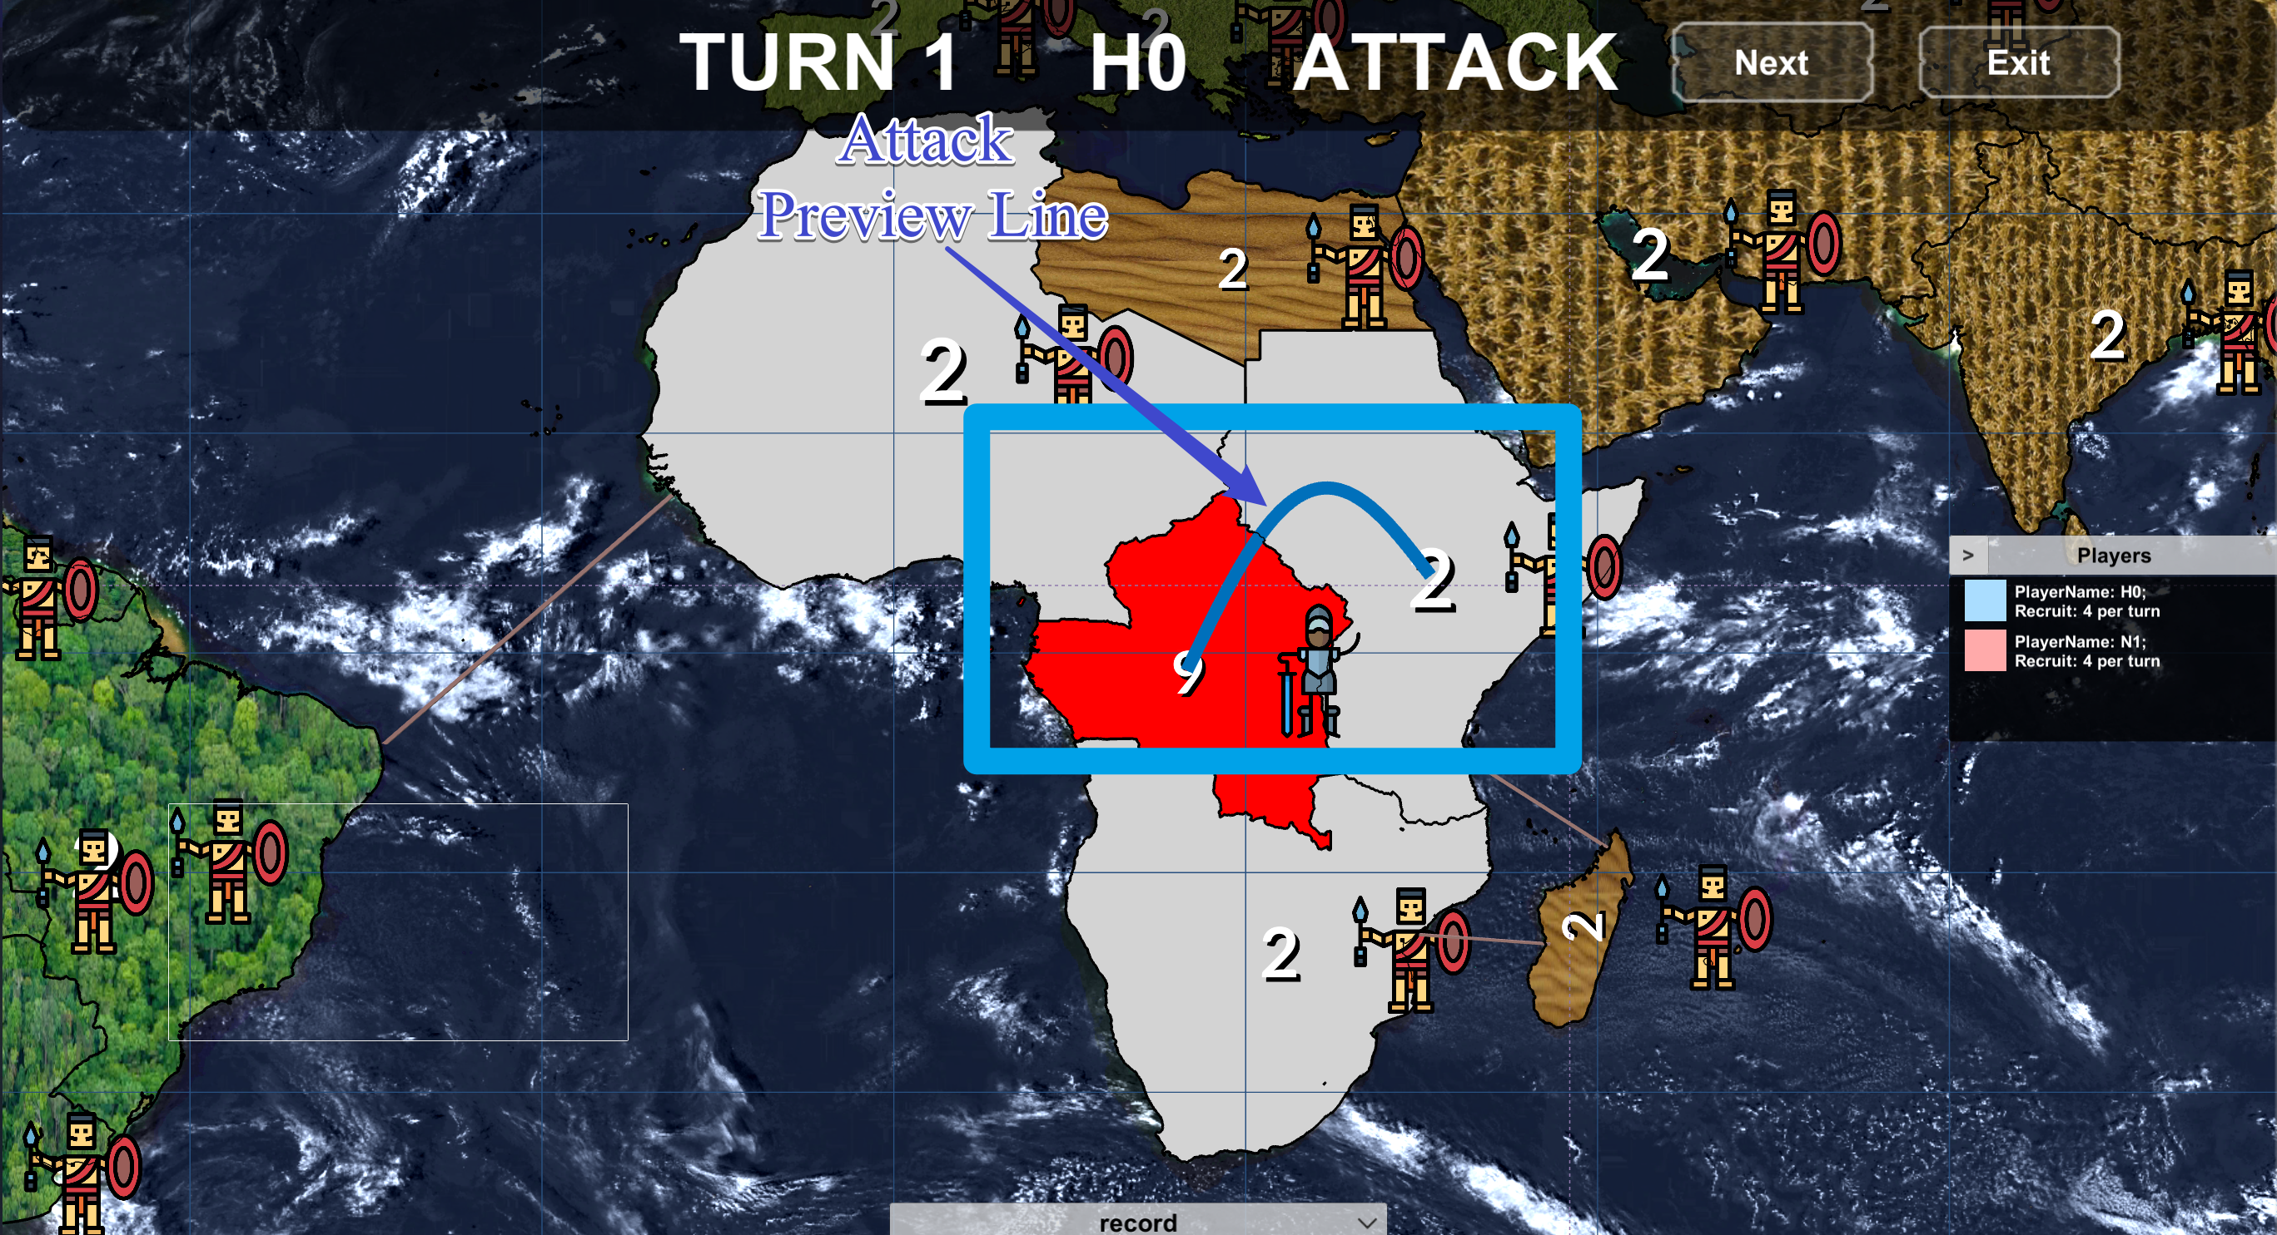

Figure 14: Attack preview line

In the project, the exclusive command is used to solve the problem. Code 18 in section 5.2.8 shows how the exclusive command work. It will rollback the previous command from the same class and then, execute the new command.

## **5.3 Implementation of Model**

### **5.3.1 Data and Data Model**

Code 21 below is complete code for “AbstraceData”, which an abstract class for the data is used in the game model. There is a total of three class implements the abstract class, namely “PlayerData”, “AreaData” and “ContinentData”. In addition, game data class can be directly converted from the JSONNode object.

public class AbstractData {  
 public readonly int ID;  
   
 public AbstractData(JSONNode rawData) {  
 ID = rawData["ID"].AsInt;  
 }  
}

Code 21: code section of Initiate Phase Controller Core

Code 22 below shows the code section of the “RiskDataModel”. It is a container class which manages all these data with their relations and it also provides a set of functions to operate these data. It clear to see that all data are directly stored in the three different lists and the relation between there are stored in the RelationMatrix. In addition, the class is encapsulated in both “RiskLogicCore” and “RiskDataManager” to provide the controller essential data.

public class RiskGameDataModel {  
 //1. Geography Data  
 //1.1 Data Model for the areas;  
 private readonly List<AreaData> areasList;  
 private readonly RelationMatrix areasAdjacencyMatrix;  
  
 //1.2 Data Model for the continents;  
 private readonly List<ContinentData> continentsList;  
 private readonly RelationMatrix continentAreasMatrix;  
   
 //2. Player Data  
 private readonly List<PlayerData> playersList;  
 private readonly RelationMatrix playerTerritoriesMatrix;  
  
 private RiskGameDataModel() {  
 //1. Initiate Area Data Model;  
 var AreaDataFile= JsonFile.GetJsonFile(FilePath.AreasDataAbsPath);  
 var areaDataConverter =

new RiskDataConverter<AreaData>(AreaDataFile.Read().AsArray);  
 areasList = areaDataConverter.GetTargetDataList();  
 var areaNum = areasList.Count;  
 areasAdjacencyMatrix = areaDataConverter.GetRelationMatrix(  
 with: "Neighbours", row:areaNum, column:areaNum  
 );  
 //2. Initiate the Continent Data Model  
 var continentDataFile = JsonFile.GetJsonFile(FilePath.ContinentsDataAbsPath);  
 var continentDataConverter =

new RiskDataConverter<ContinentData>(continentDataFile.Read().AsArray);  
 continentsList = continentDataConverter.GetTargetDataList();  
 var continentNum = continentsList.Count;  
 continentAreasMatrix = continentDataConverter.GetRelationMatrix(  
 with: "Countries", row:continentNum, column:areaNum  
 );  
 //3. Initiate the Player Data model  
 var playerDataFile = JsonFile.GetJsonFile(FilePath.PlayersDataAbsPath);  
 var playerDataConverter =

new RiskDataConverter<PlayerData>(playerDataFile.Read().AsArray);  
 playersList = playerDataConverter.GetTargetDataList();  
 var playerNum = playersList.Count;  
 playerTerritoriesMatrix = playerDataConverter.GetRelationMatrix(  
 with: "Countries", row:playerNum, column:areaNum  
 );  
 }

…  
}

Code 22: code section of Initiate Phase Controller Core

### **5.3.2 Input and Output**

Code 23 below is the code section for the “JsonFile”, which is an encapsulation of the SimpleJSON package. In addition, it provides a function to read and write local json files.

public class JsonFile {  
 private readonly AbsolutePath path;  
 private JSONNode jsonNode;

private JsonFile(AbsolutePath path) {  
 this.path = path;  
 var pathStr = File.Exists(path.Runtime) ? path.Runtime : path.Default;  
 string jsonStr;  
 if (Application.platform == RuntimePlatform.Android) { // if it is android platform  
 var reader = new WWW(pathStr);  
 while (!reader.isDone) { }  
 jsonStr = reader.text;  
 }  
 else{  
 jsonStr = File.ReadAllText(pathStr);  
 }   
 jsonNode = JSON.Parse(jsonStr);  
   
 }  
   
 public JSONNode Read() {  
 return jsonNode;  
 }  
  
 public void Write(JSONNode data) {  
 jsonNode = data;  
 }

}

Code 23: code section of Json File

### **5.3.3 Artificial Intelligent**

Figure 15 below shows the “Ontology” model in artificial intelligent. It is clear to see that the AI “Ontology” consists of three different parts: the first one is the “Enemy Territory” in the periphery of the graph, the second one is “FrontLine” which directly connects with the “Enemy Territory” and remaining nodes is “HomeLine”. The implementation of the class “RiskComputerOntology” completely follows the design of data structure BalanceGraph introduced in the section 4.7.4 BlanaceGraph.

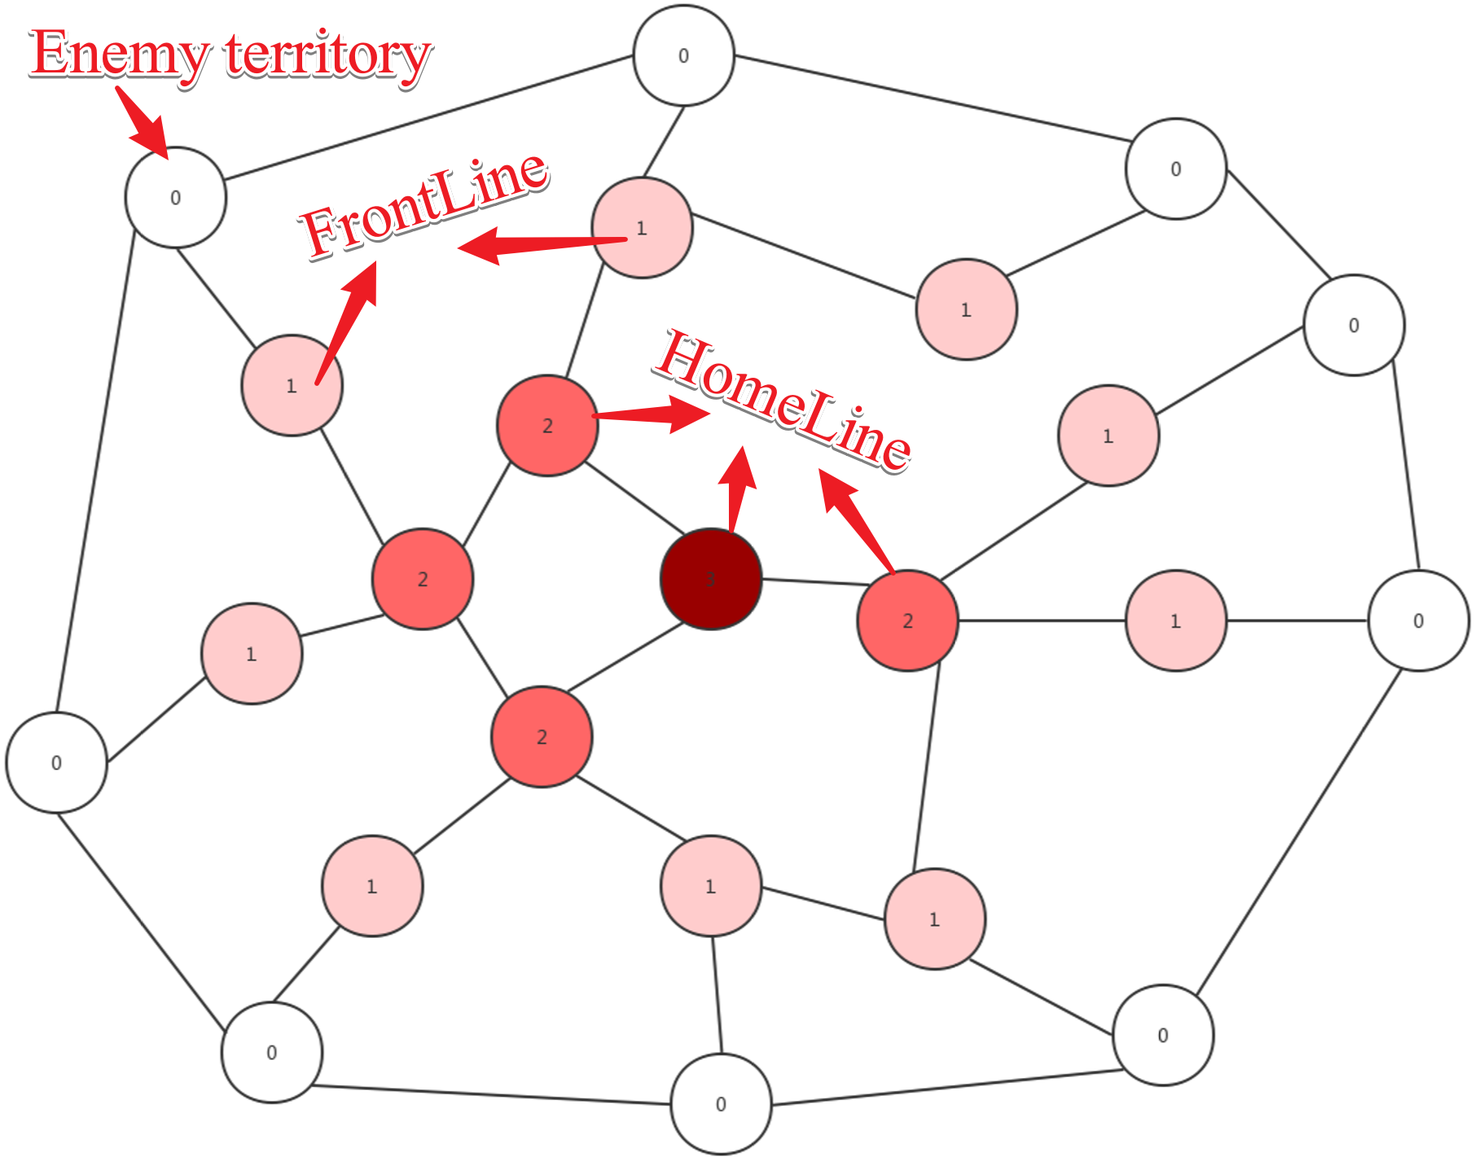

Figure 15: Ontology

Code 24 below is the code section for “Ontology”, which the class provides the AI core with essential data to produce a strategy. Generally, the class implements for the data structure “BalanceGraph”. variables frontline and home-line provides a method to access the nodes data with specific levels. The two methods “BuildGraph” and “UpdateBalances” provide methods to update data stored in Ontology and estimate the size of armies required in each territory to fortify.

public class RiskComputerOntology {  
 private readonly Dictionary<AreaData, BalanceNode> ontologyCore;  
  
 public List<BalanceNode> FrontLine => (  
 from node in ontologyCore.Values  
 where node.isFrontLine()  
 orderby node.ArmiesBalance descending  
 select node  
 ).ToList();  
   
 public List<BalanceNode> HomeFront => (  
 from node in ontologyCore.Values  
 where ! node.isFrontLine()  
 orderby node.ArmiesBalance descending  
 select node  
 ).ToList();  
   
 public void BuildGraph(){  
 var playerTerritoriesList = GetAreasListInTerritory(playerName);  
 //Add new neighbours  
 playerTerritoriesList.ForEach(playerTerritoryData => {  
 if(ontologyCore.ContainsKey(playerTerritoryData)) return;  
 var nearbyAreaDataList = GetNeighboursList(playerTerritoryData.Name);  
 var nearbyTerritoriesNodes = (  
 from nearbyAreaData in nearbyAreaDataList  
 where ontologyCore.ContainsKey(nearbyAreaData)  
 select ontologyCore[nearbyAreaData]  
 ).ToList();  
 var newNode = new BalanceNode(playerTerritoryData);  
 newNode.ConnectWithNearbyTerritories(nearbyTerritoriesNodes);  
 ontologyCore[playerTerritoryData] = newNode;  
 });  
 //Delete the neighbours which is invalid  
 var removedNodesList = new List<AreaData>();  
 foreach (var ontologyPair in ontologyCore) {  
 var ontologyAreaData = ontologyPair.Key;  
 if(playerTerritoriesList.Contains(ontologyAreaData)) continue;  
 ontologyCore[ontologyAreaData].DisconnectWithNearbyTerritories();  
 removedNodesList.Add(ontologyAreaData);  
 }  
 removedNodesList.ForEach(data=>ontologyCore.Remove(data));  
   
 HomeFront.ForEach(homeFrontNode => homeFrontNode.PrepareForLevelBoardCast());  
 FrontLine.ForEach(frontLineNode => frontLineNode.LevelBoardCast());  
 }  
   
  
 public void UpdateBalance() {  
 var level = 0;  
 List<BalanceNode> nodesInSameLevel;  
 do {  
 nodesInSameLevel = (  
 from node in ontologyCore  
 where node.Value.CurrentLevel == level  
 select node.Value  
 ).ToList();  
 nodesInSameLevel.ForEach(node => {  
 node.PrepareForBalanceBoardCast();  
 node.BalanceBoardCast();  
 });  
 level += 1;  
 } while (nodesInSameLevel.Any());  
 }

}

Code 24: code section Risk Computer Ontology

Code 25 below is the code section for the method DeployPhaseReasoning in the class “AggressiveComputerPlayerCore”. In this part, the AI player follows the rules below:

* If the size of recruit is smaller than the sum of negative balance for all frontline nodes, deploys recruits into each of these nodes as many as possible and the size of recruits equals to its balance value.
* If the size of the recruit is bigger, the AI core will increase the army’s size of these nodes to make their balance be zero and the randomly deploys remaining recruits.

public RiskStrategy<ReinforcementAction> DeployPhaseReasoning() {  
 var strategy = new RiskStrategy<ReinforcementAction>();  
 var recruitNumber = RiskLogicCore.instance.GetPlayerRecruitSize(player.Name);  
 var frontLineList = ontology.FrontLine;  
 frontLineList.ForEach(node => {  
 if (recruitNumber <= 0) return;  
 if (node.ArmiesBalance >= 0) return;  
 var armiesShortage = -node.ArmiesBalance;  
 var newAction = new ReinforcementAction(  
 areaName:node.areaData.Name, size:Math.Min(armiesShortage, recruitNumber)  
 );  
 strategy.Add(newAction);  
 recruitNumber -= armiesShortage;  
 });  
 if (recruitNumber <= 0) return strategy;  
 var tmpIndex = 0;  
 while (recruitNumber > 0) {  
 var tmpNode = frontLineList[tmpIndex % frontLineList.Count];  
 var newStrategy = new ReinforcementAction(  
 areaName: tmpNode.areaData.Name, size: 1  
 );  
 strategy.Add(newStrategy);  
 recruitNumber -= 1;  
 tmpIndex += 1;  
 }  
 return strategy;  
}

Code 25: code section for DeployPhaseReasoning in “AggressiveComputerPlayerCore”

Code 26 below is the code section for the method AttackPhaseReasoning in the class “AggressiveComputerPlayerCore”.

public RiskStrategy<MoveAction> AttackPhaseReasoning() {  
 var strategy = new RiskStrategy<MoveAction>();  
 var frontLineList = ontology.FrontLine;  
 frontLineList.ForEach(frontLineNode => {  
 var actionList = frontLineNode.ArmiesBalance >= 0  
 ? AttackWithAbsoluteNumericalSuperiority(frontLineNode)  
 : AttackWithRelativeNumericalSuperiority(frontLineNode);  
 actionList.ForEach(action => strategy.Add(action));  
 });  
 return strategy;  
}

Code 26: code section for method “AttackPhaseReasoning” in “AggressiveComputerPlayerCore”

According to the code section, it is clear to see that the aggressive computer player core will make an attacking plan for armies in frontline and the plan follows different logic in different situations.

* If the value of the army balance in a frontline node is larger than zero, the player has absolute numerical superiority in the current area, comparing with other players who occupy adjacent areas. Therefore, the player core will attack these adjacent areas which are under enemies’ control.
* Else, if the value of the army balance in the area is negative, but the local army size is larger than the maximal enemy armies in the adjacent areas, the player has relative numerical superiority in the area. Therefore, the player core will attack these adjacent enemy-territories until it loses the superiority.
* Else, the player core will not launch an attack from this territory.

Methods “AttackWithAbsoluteAdvance” and “AttackWithRelativeAdvance” implement these logics noticed. Code 27 is the code for the method “AttackWithAbsoluteAdvance”.

private List<MoveAction> AttackWithAbsoluteNumericalSuperiority(BalanceNode frontLineNode){  
 /*attack adjacent areas which are under enemies’ control*/  
 var actionList = new List<MoveAction>();  
 var frontLineAreaData = frontLineNode.areaData;  
 var nearbyAreasList = dataModel.GetNeighboursList(frontLineAreaData.Name);  
 var nearbyEnemyAreasList = nearbyAreasList.FindAll(data =>  
 dataModel.GetOwner(data.Name) != player  
 );  
 var availableAttackerSize = frontLineAreaData.ActiveArmiesSize;  
 nearbyEnemyAreasList.ForEach(neighbourData => {  
 var attackerSize = neighbourData.TotalArmiesSize;  
 var newAction = new MoveAction(frontLineAreaData.Name,neighbourData.Name,attackerSize);   
 actionList.Add(newAction);  
 availableAttackerSize -= attackerSize;  
 });  
 /*Averagely increase the size of attacker*/  
 var tmpIndex = 0;  
 while (availableAttackerSize > 0) {  
 tmpIndex = tmpIndex % nearbyEnemyAreasList.Count;  
 var enemyAreaData = nearbyEnemyAreasList[tmpIndex];  
 var newStrategy = new MoveAction(frontLineAreaData.Name, enemyAreaData.Name, 1);  
 actionList.Add(newStrategy);  
 availableAttackerSize -= 1;  
 tmpIndex += 1;  
 }  
 return actionList;  
}

Code 27: code section for method “AttackPhaseReasoning” in “AggressiveComputerPlayerCore”

Code 28 below is the code section for method “SchedulePhaseReasoning” in the class “AggressiveComputerPlayeCore”. In the method, it makes each home-line node delivery its own armies to higher level nodes which need to fortify.

public RiskStrategy<MoveAction> SchedulePhaseReasoning() {  
 var strategy = new RiskStrategy<MoveAction>();  
 ontology.HomeFront.ForEach(homeFrontNode => {  
 var homeFrontAreaData = homeFrontNode.areaData;  
 var activeArmiesSize = homeFrontAreaData.ActiveArmiesSize;  
 if (activeArmiesSize == 0) return;  
 var nodeNeighbours = homeFrontNode.NeighbourTerritoriesNodes;  
 var neighboursHighLevelNodesList = nodeNeighbours.FindAll(neighbourNode =>  
 neighbourNode.CurrentLevel < homeFrontNode.CurrentLevel  
 );  
 neighboursHighLevelNodesList.ForEach(neighbourNode => {  
 if (activeArmiesSize <= 0) return;  
 if (neighbourNode.ArmiesBalance >= 0) return;  
 var armiesShortage = -neighbourNode.ArmiesBalance;  
 var newAction = new MoveAction(  
 fromName: homeFrontAreaData.Name,  
 toName: neighbourNode.areaData.Name,   
 size: Math.Min(activeArmiesSize, armiesShortage)  
 );  
 strategy.Add(newAction);  
 activeArmiesSize -= armiesShortage;  
 });  
 var tmpIndex = 0;  
 while (activeArmiesSize > 0) {  
 tmpIndex = tmpIndex % neighboursHighLevelNodesList.Count;  
 var highLevelNodes = neighboursHighLevelNodesList[tmpIndex];  
 var newStrategy =

new MoveAction(homeFrontAreaData.Name, highLevelNodes.areaData.Name,1);   
 strategy.Add(newStrategy);  
 activeArmiesSize -= 1;  
 tmpIndex += 1;  
 }  
 });  
 return strategy;  
}

Code 28: code section for method “AttackPhaseReasoning” in “AggressiveComputerPlayerCore”

### **5.3.4 Changes in Model Design**

Similar to the controller part, the implementation of the game model is completely different from the previous game model design and strictly follows the current one in section 4.5.3.

Figure 16 below is the class diagram in “Specification and Design Document”. Compared with the current one, the class named “RiskGame” breaks the single responsibility principle because the class needs to handle the data querying and the logic method invoking from the player controller model. In addition, the design did not consider how AI execute in the game program.

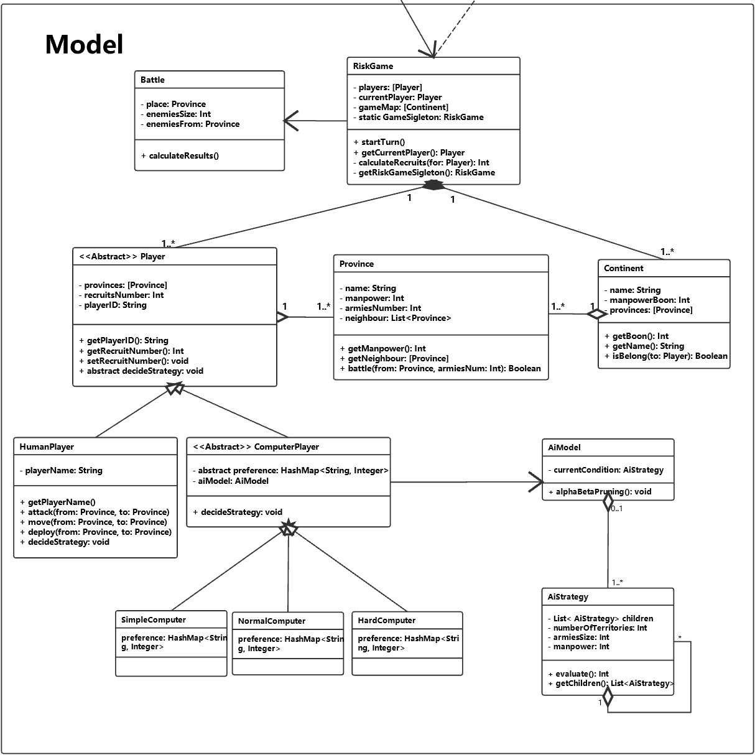

Figure 1 Previous Game Model Design

### **5.3.5 Problems Encountered on the game model**

The first problem encountered in this part is how to store and manage neighbour relations between different areas. Figure 17 describes the basic information about areas and their relations.

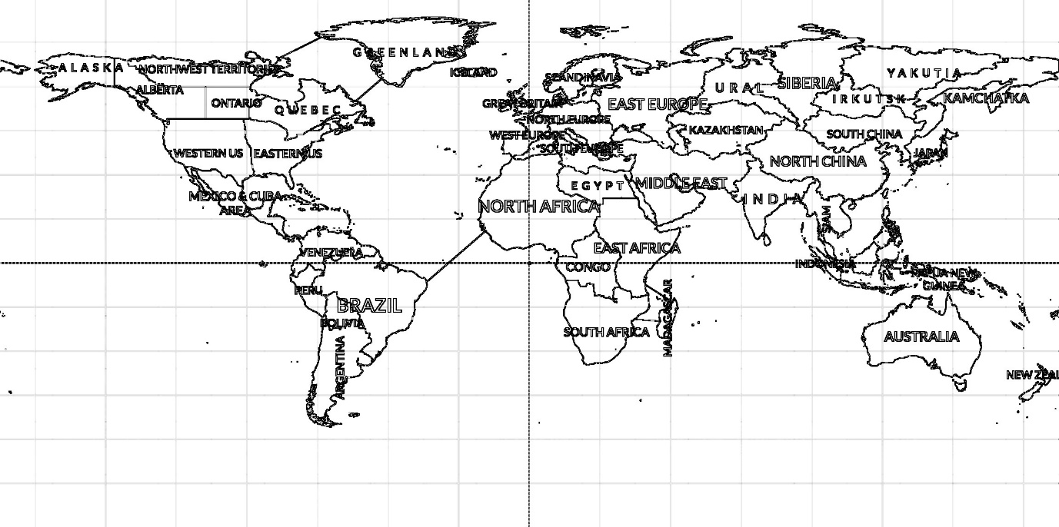

Figure 1 basic relation between each area

Based on the lecture content of CSE102 [22], the geography information on the map can be stored into an undirected graph in which a node presents an area and an edge between two nodes means that the two nodes are adjacent. Figure 18 shows the undirected graph.

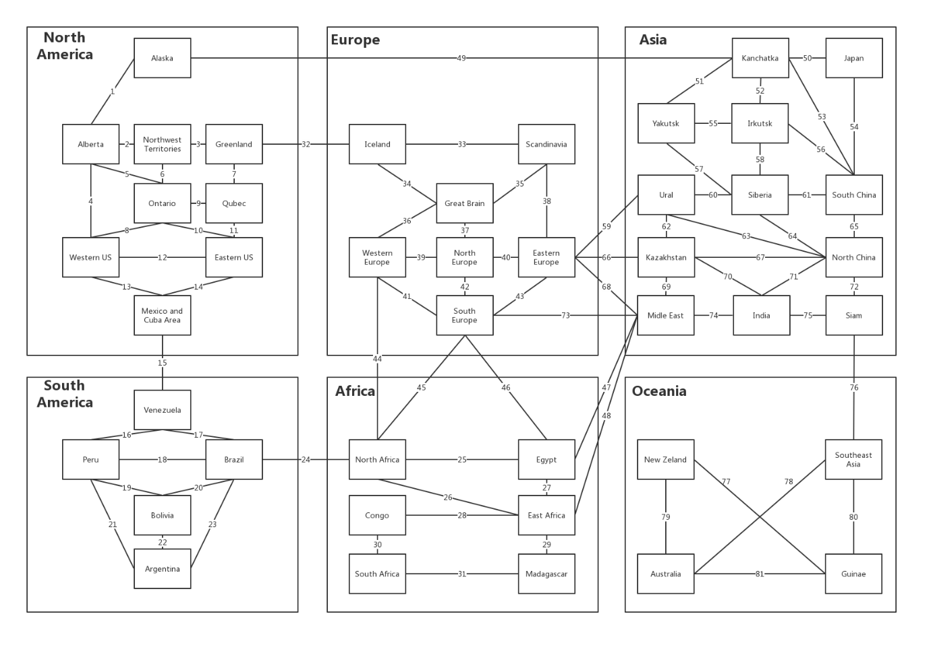

Figure 1 Undirected Graph of the game map

Therefore, the problem now is how to store an undirect graph in the program. It is notified that the adjacent matrix is a solution to the problem. Figure 19 is part of the adjacent matrix.

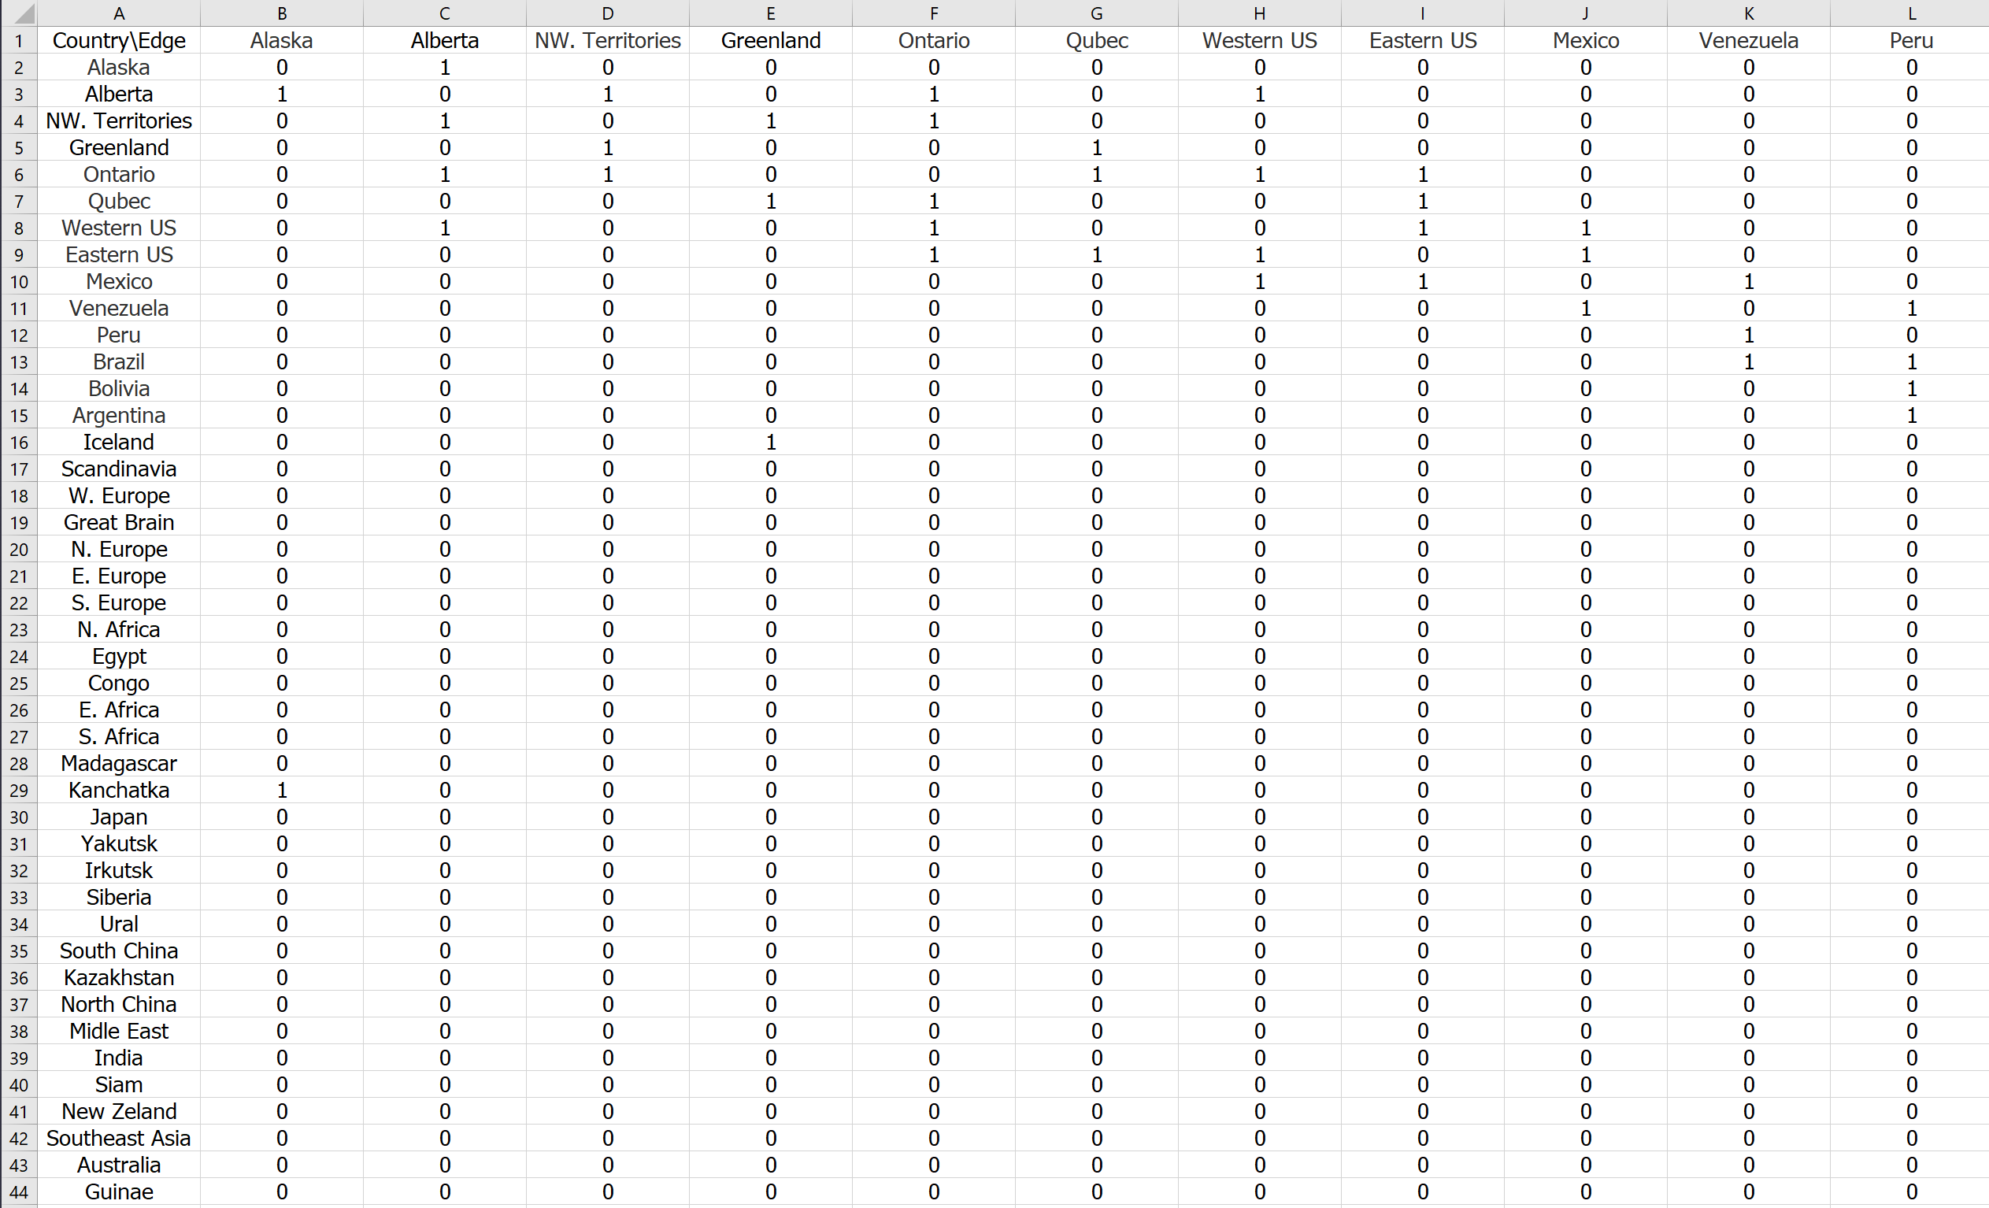

Figure1 Part of the adjacent matrix

In the project, a class named “RelationMatrix” implements the adjacent matrix in the graph. Code 29 is the complete code of the adjacent matrix.

public class RelationMatrix {  
 private readonly byte[][] matrixCore;  
  
 public RelationMatrix(int row, int column) {  
 matrixCore = new byte[row][];  
 for (var rowIndex = 0; rowIndex < matrixCore.Length; rowIndex++)   
 matrixCore[rowIndex] = new byte[column];  
 }  
  
 public void SetRelation(int row, int column, bool isExist) {  
 matrixCore[row][column] = (byte)(isExist ? 1 : 0);  
 }  
  
  
 public List<int> GetColumnIndexesWhichExistRelation(int withRow) {  
 var columnNumberList = new List<int>();  
 var rowByteArr = matrixCore[withRow];  
 for (var i = 0; i < rowByteArr.Length; i++)   
 if (rowByteArr[i] == 1) columnNumberList.Add(i);  
 return columnNumberList;  
 }  
  
 public List<int> GetRowIndexesWhichExistRelation(int withColumn) {  
 var columnNumberList = new List<int>();  
 for (var i = 0; i < matrixCore.Length; i++)   
 if (matrixCore[i][withColumn] == 1) columnNumberList.Add(i);  
 return columnNumberList;  
 }  
}

Code 29: code for class RelationMatrix

Another problem encountered is how to calculate the results of the attacking. In the original risk board game, a set of dices are used to make the result of the battle be non-deterministic. The current game design, however, completely removes the dice to reduce the complexity of the game program.

To solve the problem, the program implements a class name “RiskLogicCore” which provides a set of methods for calculating the result of different player action. The method “Attack” is a method in the class, which implement the non-deterministic calculation for the game battle. Code 30 below is the code for the method.

public bool Attack(string attackerAreaName, string defenderAreaName, int attackerSize) {  
 var attackerArea = dataModel.GetArea(attackerAreaName);  
 var defenderArea = dataModel.GetArea(defenderAreaName);  
 var defenderSize = defenderArea.TotalArmiesSize;  
 var randomNum = 0.75 * new Random().Next(1,2);  
 var attackerBattleDamage = (int)Math.Ceiling(0.8 * randomNum* defenderSize);  
 var defenderBattleDamage = (int)Math.Ceiling(0.6 * randomNum* attackerSize);  
 var attackerLeft = attackerSize > attackerBattleDamage ?  
 attackerSize - attackerBattleDamage : 0;  
 var defenderLeft = defenderSize > defenderBattleDamage ?   
 defenderSize - defenderBattleDamage : 0;  
  
 if (defenderLeft > 0) { // If defender win  
 attackerArea.ActiveArmiesSize -= attackerSize;  
 attackerArea.InactiveArmiesSize += attackerLeft;  
 defenderArea.ActiveArmiesSize = 0;  
 defenderArea.InactiveArmiesSize = defenderLeft;  
 return false;  
 }  
 else { // If attacker win  
 attackerArea.ActiveArmiesSize -= attackerSize;  
 defenderArea.InactiveArmiesSize = attackerLeft;  
 defenderArea.ActiveArmiesSize = 0;  
 var attacker = dataModel.GetOwner(attackerAreaName);  
 dataModel.SetOwner(defenderAreaName, attacker.Name);  
 return true;  
 }  
}

Code 30: code section for Attack

## **5.4 Test**

### **5.4.1 System Test**

Because there is not an automatic system test tool for Unity, system testing is completely manual. There are more details (snapshots) about the system testing in appendix 02.

|  |  |
| --- | --- |
| **ID** | System Test Case 01 |
| **Description** | A user configures the number and type of the game player |
| **Test Steps** | The game system requires the number of players from the user. After the user types a number, the system will check the validation. **if** it is valid,   the system will store the number of the player. **else**  the system will notify the user, the number is invalid. and then **for** all other players,  the user selects the player type. |
| **Expected Result** | The game starts with the correct number and type of players. |
| **Actual Result** | It is the same as the expected result. |

|  |  |
| --- | --- |
| **ID** | System Test Case 02 |
| **Description** | Click different game map areas |
| **Test Steps** | Click an area which belongs to the test player in recruit phase.  Click an area which belongs to the test player in the attack phase.  Click an area which belongs to the test player in Initiate phase.  Click an area which does not belong to the test player. |
| **Expected Result** | **if** the area does not belong to the player, then nothing occurs;  **if** the area belongs to the player and the player is in recruiting or attacking phase, then the area will be highlighted;  **if** the area belongs to the test player, but the player is in the initiating phase, then nothing occurs. |
| **Actual Result** | It is the same as the expected result. |

|  |  |
| --- | --- |
| **ID** | System Test Case 03 |
| **Description** | Deploy recruits in recruiting phase |
| **Test Steps** | Click one of the test player territories.  And then, there will be a dialogue to require the size of the recruit to reinforce.  After that, select the size of the recruit and click the confirm button.  Check the number of armies on the clicked area. |
| **Expected Result** | The number of armies increases by the size of recruits selected. |
| **Actual Result** | It is the same as the expected result. |

|  |  |
| --- | --- |
| **ID** | System Test Case 04 |
| **Description** | Attack others’ territory. |
| **Test Steps** | Click one of the test player’s territories.  And then, click any adjacent area of the selected area, which does not belong to the test player.  After that, there will be a dialogue which requires the test player to select the size of armies to attack.  Select the size of attackers and click confirm button.  Check the result of the battle. |
| **Expected Result** | If the test player wins the battle, it will occupy the area.  Else nothing happens. |
| **Actual Result** | It is the same as the expected result. |

|  |  |
| --- | --- |
| **ID** | System Test Case 05 |
| **Description** | Move armies from test player a territory to another adjacent territory. |
| **Test Steps** | Click one of the test player’s territories.  And then, click an adjacent territory of the selected area.  After that, there will be a dialogue which requires the test player to select the size of armies to move.  Select the size of armies and click the confirm button.  Check the result of the movement. |
| **Expected Result** | The specified number of armies moves from one territory to another one. |
| **Actual Result** | It is the same as the expected result. |

|  |  |
| --- | --- |
| **ID** | System Test Case 06 |
| **Description** | The test player wins the game |
| **Test Steps** | The test player occupies all forty-two areas |
| **Expected Result** | A congratulation message is shown on the screen. |
| **Actual Result** | It is the same as the expected result. |

|  |  |
| --- | --- |
| **ID** | System Test Case 07 |
| **Description** | The test player loses the game |
| **Test Steps** | The test player loses all territory |
| **Expected Result** | A message about defeated is shown on the screen. |
| **Actual Result** | It is the same as the expected result. |

### **5.4.1 Cluster Test**

Unity provides a set of APIs to debugs and output logs on console. In the project, these APIs can be used to implements the cluster test.

|  |  |
| --- | --- |
| **ID** | Cluster Test Case 01 |
| **Description** | Communication between GameView and GameController |
| **Test Steps** | Invoke map events, and then check log in PlayerManager;  Create a command and then make the invoke to execute the command, after that, check the system logs about the map updater. |
| **Expected Result** | There are system logs show player-manager and the map updater receives the correct information. |
| **Actual Result** | It is the same as the expected result. |

|  |  |
| --- | --- |
| **ID** | Cluster Test Case 02 |
| **Description** | Communication between GameController with GameModel |
| **Test Steps** | Create a command and then make the invoke to execute the command, after that, check the system logs about the risk logic core.  Query model data from the player controller class after that, check the response message and the system logs about the Query Manager  Require a strategy from a computer player controller, check the response message and the system logs about the AI core. |
| **Expected Result** | There are system logs show the risk logic core, query manager and AI core receive the correct information. |
| **Actual Result** | It is the same as the expected result. |

### **5.4.1 Unit Test**

Unity provides a powerful Unit test tool, “NUnit” test framework. It is JUnit like test tool which provides a kind of automatic test mechanism. In the project, all class test and operation test is based on the “NUnit”. The test program can be found in Appendix 03.

|  |  |
| --- | --- |
| **ID** | Unit Test Case 01 |
| **Description** | Tests area data list in data model. |
| **Test Steps** | Access the area data in local json file;  Access the area data in the data model;  Compares the two data. |
| **Expected Result** | The area data stored in a local json file and data model are the same. |
| **Actual Result** | It is the same as the expected result. |

|  |  |
| --- | --- |
| **ID** | Unit Test Case 02 |
| **Description** | Tests continent data list in data model. |
| **Test Steps** | Access the continent data in local json file;  Access the continent data in data model;  Compares the two data. |
| **Expected Result** | The continent data stored in a local json file and data model are the same. |
| **Actual Result** | It is the same as the expected result. |

|  |  |
| --- | --- |
| **ID** | Unit Test Case 03 |
| **Description** | Tests data model operation. |
| **Test Steps** | Test the function of the setting and getting area owner;  Test the function of getting the area data.  Test the function of getting neighbours. |
| **Expected Result** | The continent data stored in a local json file and data model are the same. |
| **Actual Result** | It is the same as the expected result. |

|  |  |
| --- | --- |
| **ID** | Unit Test Case 04 |
| **Description** | Tests data view updater. |
| **Test Steps** | Update the game area colour  Create a game trajectory  Create a label. |
| **Expected Result** | The continent data stored in a local json file and data model are the same. |
| **Actual Result** | It is the same as the expected result. |

# **6. Evaluation**

## **6.1 Functional Point**

As the design document described, Functional point will be used to evaluate the quality of the program and the efforts needed to implement the program [21]. The reason why uses the functional point here is that it provides a function to convert the efforts and the workload into the integer making these data more obvious.

Table 04 below describes predefined weight parameters of different functions in the game to calculate the functional point. To calculate the Function-Point of the program, we first respectively calculate the product between the number of each kind of function and their predefined weight. The Function-Point of the program is the sum of these products.

|  |  |  |  |
| --- | --- | --- | --- |
| **Function** | **Weight (1-10)** | | |
| **Simple** | **Normal** | **Hard** |
| The encapsulation of the game map | 2 | 3 | 8 |
| The encapsulation of GUI Components | 1 | 3 | 5 |
| The implementation of the command | 4 | 6 | 8 |
| The implementation of the player controller | 3 | 5 | 8 |
| The implementation of the data model | 2 | 4 | 8 |
| The implementation of Game AI Core | 4 | 6 | 10 |
| The encapsulation of local data | 2 | 4 | 6 |

Table 04: Table for function point weight

In the project, there are totally 56 classes and at least 100 public methods. Tables 05 shows the number of different kinds of method

|  |  |  |  |
| --- | --- | --- | --- |
| **Function** | **The number of methods** | | |
| **Simple** | **Normal** | **Hard** |
| The encapsulation of the game map | 5 | 10 | 3 |
| The encapsulation of GUI Components | 4 | 15 | 2 |
| The implementation of the command | 4 | 9 | 2 |
| The implementation of the player controller | 10 | 5 | 4 |
| The implementation of the data model | 18 | 2 | 1 |
| The implementation of Game AI Core | 3 | 3 | 3 |
| The encapsulation of local data | 6 | 0 | 1 |

Table 04: Table for the number of functions

Then, according to the data from two tables, the function point of the game program is 426.

## **6.2 Self-evaluation**

The project also uses self-evaluation to evaluate program quality. Table 05 below is the criteria used in self-evaluation.

|  |
| --- |
| **Criteria** |
|
| Are the game rules complex? |
| Is the game interface well-designed? |
| Is the game AI work efficiently? |

*Table 05: The table for the criteria*

In this part, the document will directly compare the game with the other two risk game namely, “Warzone” and “Hasbro Risk”. In addition, the comparison bases on the criteria listed.

In term of game rules, as the document noticed in section 2.2 existing solution, the Hasbro game is more comprehensive but may be too complex for many players to enjoy the game. The game rule of Warzone is well-designed and the average game playing time is nearly 15 mins. Compared with the risk game in the project, the warzone is better also. The drawback of the risk game in the project is the non-deterministic mechanism which needed to be improved.

Regarding the game interface, the Hasbro risk is best. Compared with the project, it is better because it has an excellent user interface design and assets. The game map of the risk game in the project is more detailed and suitable than the warzone’s game map because of the limitation of the browser and the mechanism to identify the continents and areas. But the warzone’s game interface is also well-designed and is better than the project in some other respects such as the design of game interface components.

Comparing all three game, the Hasbro Risk implements the most efficient and complexity game AI. Compared with the other two games, the AI for the game in the project is not smart enough in some situations, for example, in the conservative AI player, the logic, that the player will not attack adjacent enemies except it makes sure that it has absolute numerical superiority, may cause the computer player infinite looping.

## **6.3 AI Evaluation**

To evaluate the efficiency of three different AI players, the pure computer player game (computer player versus computer player game) is executed as an experiment. In addition, there will be two players in each game, therefore, it may be random AI vs conservative AI, random AI vs aggressive AI or aggressive AI vs conservative AI). Table 06 records the result of these game.

|  |  |  |  |
| --- | --- | --- | --- |
| **ID** | **Types** | **Winner** | **Turn Number** |
| Experiment 01 | random AI vs conservative AI | conservative AI | 18 |
| Experiment 02 | random AI vs conservative AI | conservative AI | 15 |
| Experiment 03 | random AI vs conservative AI | conservative AI | 20 |
| Experiment 04 | random AI vs aggressive AI | aggressive AI | 15 |
| Experiment 06 | random AI vs aggressive AI | aggressive AI | 8 |
| Experiment 07 | random AI vs aggressive AI | aggressive AI | 10 |
| Experiment 08 | conservative AI vs aggressive AI | aggressive AI | 10 |
| Experiment 08 | conservative AI vs aggressive AI | aggressive AI | 16 |
| Experiment 08 | conservative AI vs aggressive AI | conservative AI | 25 |

*Table 05: The table for the criteria*

According to the result of 12 experiments in the table, it clear to see compare with the other two kinds of computer player, the aggressive is more efficient it and the proportion of winning is almost 90%. And the game turn in each experiment keeps in 20 turns and time for each experiment is nearly 10 mins.

# **7. Learning Point**

In this part, the document will describe learning points in the project from three different aspects namely, programming skill, project management and lecture content.

## **7.1 Lecture Content**

* The design part of the document strictly follows the structure of the object-oriented design process introduced from Module COMP201 (including, “Architecture Design”, “Abstract Specification”, “Components Design”, “Data structure Design” and “Data structure Design”) [23]. It makes me put what I learn in the COMP 201 lecture into practice.
* In addition, the program strictly follows the developing process model “Waterfall Model”. Therefore, the project makes me know the complete process of the process model.
* In the project, I implement various design patterns introduced from COMP319 (including singleton, abstract factory, builder, command and MVC) [21]. It makes me be able to use these patterns correctly and suitably.
* In the test part, I use many test methodology and automatic test tools introduced from COMP 220 (including integration test, cluster test, unit test and NUnit) [24]. It makes me be able to write a test case based on the NUnit test framework.
* In the game program, I implement many algorithms and data structure in CSE102 and COMP212 [22][5]. It makes me know the situation where these data structure and algorithms should be used.

## **7.2 Programming Skill**

* To implement the game, I finished an online Unity Game developing module named “Developing a Unity Game” on Cousera. The module makes me be familiar with the basic APIs in Unity library and syntax of C#.
* There are almost 10,000 lines of code in the final game program. The implementation process improves my programming capability.
* In addition, to implement the test case, the NUnit test framework is essential. Therefore, I learn the usage of the framework by myself and independently implements ten test cases.

## **7.3 Project Management**

* In the project, I found that it is easy for me to postpone the submission of the assessment. I solve the problem by distributing a serval month task into a series of one-day tasks and strictly follows the time schedule in the Gatt chart.
* However, if tasks have already delayed, what should we do to handle the tasks which are already delayed. In this situation, redraw the Gatt Chart is essential and then, follows the new schedule instead of the old one.
* I also learn that design and implementation may be completely different. In the project, the design document is completely changed. It is the same as the user interface whose design has changed three times.
* During the project, I found it is easier for me to deviate from the most important functionality to focus on trivial one. To solve the problem, I follow the method introduced in module COMP319 to list priority for each functionality and follows the priority in the list to implements the project.

# **8. Professional Issues**

The British Computer Society (BCS) provides a set of the professional standards of competence, conduct and ethical practice which all software developer should adhere to in the United Kingdom [25]. The game project completely follows these standards.

## **8.1 Code of Good Practice**

* In the Maintain Your Technical Competence of the codes of practice, it describes the developer should seek to improve own IT skills through books or lectures [26]. The project completely adheres the criteria because, for implementing the project, I finish the two Coursea courses and obtain the certification of them.
* In the Adhere to Regulations part in the codes of practice, it describes that the program shall follow standards relevant to the organisation's business, technology [26]. The program satisfies the requirement due to the code strictly follows the MS C# programming guide [27].
* In the “Use Appropriate Methods and Tools” requires that the program method or tools should be up to date. The program development bases on the newest release version of the C# and Unity Engine.
* In the “Respect the Interests of your Customers” part, it requires to describe possible personal gains, financial [26]. The project is the final year project so it will not be openly released online. So, it impossible to gain any financial benefits.
* In the “Software Development” part, it describes that the code should be scalability, readability and each class should clearly state its objectives, scope, features, facilities. Because, the project code follows the SOILD principle namely, “Single responsibility principle”, “Open–closed principle”, “Liskov substitution principle”, “Interface segregation principle” and “Dependency inversion principle” introduced in COMP319 [21][28], it is scalable, readable and single responsible.

## **8.2 Conduct**

* In the “Public Interest” part, the document requires to regard the third parties right and public health privacy etc [29]. The program is an offline game. Therefore, it is impossible to break the rule. In addition, it requires that the project should avoid any possible discrimination, in the game anything will not refer to discrimination.
* In the “Professional Competence and Integrity” part, it requires the developer to accepts the advice and criticisms of the others. The code is open source on the GitHub so that, no matter who can directly give me her/his opinion without authorisation.

# **9. Bibliography**

[1] Parker Brothers, *RISK The World Conquest Game*. MA 01915: Beverly, 1993.

[2] “How to play Risk | UltraBoardGames.” [Online]. Available: https://www.wikihow.com/Play-Risk. [Accessed: 27-Apr-2019].

[3] J. Schell, “Chapter Four - The Game Consists of Elements,” in *The Art of Game Design*, J. Schell, Ed. Boston: Morgan Kaufmann, 2008, pp. 39–46.

[4] D. HATFIELD, “Risk: Factions Review - IGN,” *Imagine Games Network*, 2012. [Online]. Available: https://uk.ign.com/articles/2011/03/16/risk-factions-review. [Accessed: 19-Apr-2019].

[5] O. Michail, “Distributed Systems COMP 212 Lecture 8 Othon Michail.”

[6] “UK Games Industry Fact Sheet October 2018,” London, 2018.

[7] “List of The 200+ Best Board Games of All Time and Tabletop Games,” *Ranker Community*, 2019. [Online]. Available: https://www.ranker.com/crowdranked-list/the-best-board-games-of-all-time. [Accessed: 17-Apr-2019].

[8] “Risk Desktop Version Statistical Data,” *SteamSpy*, 2019. [Online]. Available: https://steamspy.com/app/227920. [Accessed: 19-Apr-2019].

[9] “RISK Android Version Statistical Data,” *Google Play*, 2019. [Online]. Available: https://play.google.com/store/apps/details?id=com.hasbro.riskbigscreen&hl=en&showAllReviews=true. [Accessed: 19-Apr-2019].

[10] “About - Warzone - Better than Hasbro’s RISK® game - Play Online Free.” [Online]. Available: https://www.warzone.com/About. [Accessed: 28-Apr-2019].

[11] H. Dongyan, “Introduction of the Game Industry | Coursera,” *Coursea*, 2012. [Online]. Available: https://www.coursera.org/learn/youxi-chanye-gailun/home/welcome. [Accessed: 28-Apr-2019].

[12] J. Schell, *The art of game design : a book of lenses*. Elsevier/Morgan Kaufmann, 2008.

[13] jMonkeyEngine, “jMonkeyEngine Documentation,” *jMonkeyEngine*, 2016. [Online]. Available: https://wiki.jmonkeyengine.org/. [Accessed: 28-Apr-2019].

[14] “PlayCanvas WebGL Game Engine.” [Online]. Available: https://playcanvas.com/. [Accessed: 28-Apr-2019].

[15] M. Wolf, “An Intelligent Artificial Player for the Game of Risk,” 2005.

[16] “Gameplay Basics - Warzone Wiki.” [Online]. Available: https://www.warzone.com/wiki/Gameplay_Basics. [Accessed: 28-Apr-2019].

[17] L. Hogben, *Handbook of linear algebra*. Boca Raton: Chapman & Hall/CRC, 2007.

[18] R. Bronson, G. B. Costa, and J. T. Saccoman, *Linear algebra : algorithms, applications, and techniques.* .

[19] D. Pal, *Data Structure and Algorithm with C*. Alpha Science International, 2018.

[20] “Unity - Manual: UI.” [Online]. Available: https://docs.unity3d.com/Manual/UIToolkits.html. [Accessed: 06-May-2019].

[21] S. Coope, “COMP319 Lecture 03-04.” [Online]. Available: https://cgi.csc.liv.ac.uk/~coopes/comp319/powerpoint/. [Accessed: 07-May-2019].

[22] Wenjin Lu, “week4-lecture1.ppt - CSE102 Algorithmic Foundations And Problem Solving.” [Online]. Available: https://www.coursehero.com/file/41032951/week4-lecture1ppt/. [Accessed: 08-May-2019].

[23] Sebastian Coope, “COMP201 Software Engineering.” [Online]. Available: https://cgi.csc.liv.ac.uk/~coopes/comp201/. [Accessed: 09-May-2019].

[24] Sebastian Coope, “COMP220 Software Development Tools.” [Online]. Available: https://cgi.csc.liv.ac.uk/~coopes/comp220/. [Accessed: 09-May-2019].

[25] “BCS Codes of Conduct and Practice.” [Online]. Available: https://www.cs.uct.ac.za/mit_notes/ethics/htmls/ch04s04.html. [Accessed: 09-May-2019].

[26] “The British Computer Society Code of Good Practice.”

[27] “C# Programming Guide | Microsoft Docs.” [Online]. Available: https://docs.microsoft.com/en-us/dotnet/csharp/programming-guide/index. [Accessed: 09-May-2019].

[28] S. Metz, *SOLID Object-Oriented Design*. 2009.

[29] “Trustee Board Regulations Schedule 3 v5-Code of Conduct for BCS Members BCS, THE CHARTERED INSTITUTE FOR IT TRUSTEE BOARD REGULATIONS-SCHEDULE 3 CODE OF CONDUCT FOR BCS MEMBERS.”

# **10. Appendices**

Appendices 01: Design Document;

Appendices 02: Program Code

Appendices 03: Test Code